ĐẠI HỌC QUỐC GIA THÀNH PHỐ HỒ CHÍ MINHTRƯỜNG ĐẠI HỌC CÔNG NGHỆ THÔNG TINKHOA CÔNG NGHỆ PHẦN MỀM



**BÁO CÁO ĐỒ ÁN 1**

**ĐỀ TÀI:**

**DUNGEON CRAWLER GAME**

Giảng viên:

Trần Anh Dũng

Sinh viên thực hiện:

Nguyễn Minh Thiện – 19522262

*Thành phố Hồ Chí Minh, năm 2022*

VIETNAM NATIONAL UNIVERSITY - HO CHI MINH CITYUNIVERSITY OF INFORMATION TECHNOLOGYTHE FACULTY OF SOFTWARE ENGINEERING

**PROJECT 1 REPORT**

**PROJECT:**

**DUNGEON CRAWLER GAME**

Instructor:

Trần Anh Dũng

Student:

Nguyễn Minh Thiện – 19522262

*Ho Chi Minh City, 2022*

**Document change record sheet**

|  |  |  |  |
| --- | --- | --- | --- |
| **Date** | **Version** | **Description** | **Authors** |
| 25/9/2021 | 0.1 | Added basic game function like player movement shooting, background, basic collision | Nguyễn Minh Thiện.  Nguyễn Nhật Huy |
| 02/1/2022 | 1.0 | Adding layout | Nguyễn Minh Thiện.  Nguyễn Nhật Huy |
| 05/1/2022 | 1.1 | Finalize report of v1.0 of the game | Nguyễn Minh Thiện.  Nguyễn Nhật Huy |
| 15/6/2022 | 1.2 | Update report for v1.2.5 of the game | Nguyễn Minh Thiện |

**Disclaimer:**

This game is used as a study material we do not intend to publish or making a profit from this. If anyone who read this document and saw their assets in our game without your permission, please don’t sue us

# Table of Contents

Table of Contents 2

Images Table of Content 7

ACKNOWLEDGEMENT 8

DETAILED OUTLINE 9

CHAPTER I: INTRODUCTION 14

I. Basic Information 14

1. Group Information 14

2. Project Information 14

3. Technology used 14

3.1. Unity 14

3.2. C# 15

3.3. Github 16

3.4. VSCode 16

II. Statement of the Project 17

1. Game concept 17

1.1. Purpose of the game 17

1.2. Story 17

1.3. Features 18

2. Brief description of entities and objects in the game 18

2.1. Entities 18

2.1.1. Player 18

2.1.2. Slime 18

2.1.3. Archer 19

2.1.4. Shield Enemy 19

2.1.5. Bomber Enemy (Also known as SuicideEnemy) 19

2.1.6. Boss Golem 19

2.1.7. Shop NPC 19

2.1.8. Bringer of Death Boss 19

2.2. Objects 20

2.2.1. Bullet 20

2.2.2. Portal 20

2.2.3. Buffs 20

2.2.4. Non-Moving Objects 20

2.2.5. Drops 20

2.2.6. Item 20

3. Functional requirements 20

4. Non-functional requirements 21

4.1. Interface requirements 21

4.2. Game balancing requirements 21

4.3. Compatibility requirements 21

4.4. Quality and efficiency requirements 21

CHAPTER II: USE CASE 22

I. User story 22

II. Use case models 23

1. Use case diagrams 23

1.1. Player 23

1.2. Slime 24

1.3. Archer 25

1.4. Golem 26

1.5. ShopNPC 27

1.6. Shield Enemy 27

1.7. Bomber 28

1.8. Audio Manager 28

1.9. Bringer Of Death Boss 29

2. Actor list 29

3. Use case list 30

4. Use case specification 33

4.1. Play game 33

4.2. Exit menu 33

4.3. Pause game 34

4.4. Save game 34

4.5. New game 35

4.6. Load game 35

4.7. Restart game 36

4.8. Interact with interactable objects/NPC 36

4.9. Melee Slash 37

4.10. Firing projectiles 37

4.11. Consume buffs 38

4.12. Check restrict movement 38

4.13. Check HP 39

4.14. Die 39

4.15. Take damage 40

4.16. Moving around 40

4.17. Melee Attack 41

4.18. Seek Player 41

4.19. Go idle 42

4.20. Slam 42

4.21. Fire laser 43

4.22. Roll 43

4.23. Fire arm 44

4.24. Check Cooldown 44

4.25. Summon Pillars 45

4.26. Pulling player 45

4.27. Aim 46

4.28. Interact with NPC 46

4.29. Display purchase state 47

4.30. Trade coins 47

4.31. Verify Eligibility 48

4.32. Explode 48

4.33. Shield Take Damage 49

4.34. Activate Shield 49

4.35. Deactivate Shield 50

4.36. Teleport 50

4.37. Clone 50

4.38. Cast Spell 51

4.39. Play Sound 51

4.40. Play Soundtrack 52

4.41. Remove Sound 52

4.42. Fade Soundtrack 53

4.43. Get Audio Clip 53

4.44. Check Sound Availability 54

CHAPTER III: ANALYSIS DESIGN 55

I. Classes Analysis 55

1. Class diagrams 55

1.1. Player and Enemy class Diagram 55

1.2. Interactable Class Diagram 56

1.3. Menu and Managers Class Diagram 56

2. List of classes and relationships 57

2.1. Classes 57

2.2. Relationships 58

3. Classes in details 60

II. State Diagrams 80

1. Player state diagram 80

2. Slime state diagram 81

3. Archer state diagram 82

4. Golem state diagram 83

5. Bullet state diagram 84

6. Non-Moving Object state diagram 85

7. ShopNPC state diagram 86

8. Buff state diagram 87

9. ShieldEnemy state diagram 88

10. Bomber state diagram 89

11. BringerOfDeathBoss state diagram 90

I. Player data 92

II. Modifiers Data 92

CHAPTER V: STRUCTURAL DESIGN 94

I. Game design 94

1. Core Game Loop 94

2. Progression 94

II. Software design 94

III. Design Patterns Use 95

CHAPTER VI: INTERFACE DESIGN 96

I. Regulation 96

II. List of UI 96

III. Details description 96

1. Main menu screen 96

2. Player’s Health bar 98

2.1. Circular health bar 98

2.2. Status effect bar 98

3. Player stats sheet 98

4. Number Pop up 99

5. Player exit to menu and retreat to hideout UI 100

6. Tutorial UI 101

7. Coins counter 101

8. NPCShop 101

9. Interact with object buttons 103

10. Item tooltip 103

11. Inventory 104

CHAPTER VII: INSTALLATION 105

I. Unity Hub and Editor 105

II. The game 106

CHAPTER VIII: CONCLUSION 107

I. Result 107

II. Limitations 107

III. Future Scope 107

REFERENCES 109

1. Unity 109

2. Unity Basic Tutorial (YouTube) 109

3. Unity UI tutorial (YouTube/Forums) 109

4. Assets “borrowed” 110

5. Creating assets/VFX tutorial and tool use to create assets 110

6. Path finding 110

7. Buff weight and pool references 110

8. Fire rate reference 110

9. Player’s Dash tutorial 110

10. Audio Manager tutorial 111

11. Item tooltip tutorial 111

WORKLOAD DISTRIBUTION 112

# Images Table of Content

Image 1: Unity Logo 13

Image 2: C# logo 14

Image 3: Github logo 15

Image 4: VSCode logo 15

Image 5: Player Use Case Diagram 22

Image 6: Slime Use Case Diagram 23

Image 7: Archer Use Case Diagram 24

Image 8: Golem Use Case Diagram 25

Image 9: Shope NPC Use Case Diagram 26

Image 10: Shield Enemy Use Case Diagram 26

Image 11: Bomber Use Case Diagram 27

Image 12: Audio Manager Use Case Diagram 27

Image 13: Bringer of Death Boss Use Case Diagram 28

Image 14: Player and Enemies Class Diagram 54

Image 15: Interactable Class Diagram 55

Image 16: Menu and Managers Class Diagram 55

Image 17: Player State Diagram 79

Image 18: Slime State Diagram 80

Image 19: Archer State Diagram 81

Image 20: Golem State Diagram 82

Image 21: Bullet State Diagram 83

Image 22: Non-Moving Object State Diagram 84

Image 23: Shop NPC State Diagram 85

Image 24: Buff State Diagram 86

Image 25: Shield Enemy State Diagram 87

Image 26: Bomber State Diagram 88

Image 27: Bringer of Death Boss State Diagram 89

Image 28: The game structural design 93

Image 29: Main menu UI 96

Image 30: Save slots options UI 97

Image 31: Player Health bar and Status Effect bar 97

Image 32: Player Stat Sheet UI 98

Image 33: Damage Pop Up 98

Image 34: Exit to main menu button UI 99

Image 35: Retreat button UI 99

Image 36: Retreat Confirmation Button UI 99

Image 37: Tutorial UI 100

Image 38: Coin Counter UI 100

Image 39: NPC Dialogue 1 101

Image 40: NPC Dialogue 2 102

Image 41: Interact Button UI 102

Image 42: Item Tooltip UI 103

Image 43: Inventory UI 103

# ACKNOWLEDGEMENT

After studying and training at the Faculty of Software Engineering, University of Information Technology - Vietnam National University, Ho Chi Minh City, we have been equipped with basic knowledge and practical skills to be able to do Project 1 course.

To be able to fnish this course we would like to express our deepest gratitude toward those who made this all possible:

The Board of Directors of the University of Information Technology - Vietnam National University, Ho Chi Minh City for creating favorable conditions in terms of facilities with a modern library system and with a variety of books and documents that are convenient for searching and researching information.

We would like to express our sincere thanks to Mr. Tran Anh Dung for his enthusiastic helps and guidances in scientific thinking and working methods. Those are very valuable suggestions not only in the process of doing this project, but also as a steppingstone for us in the process of studying and setting up a career in the future.

Next, we would like to thank Brackeys, Code Monkey, Blackthornprod and various other youtubers for making all those wonderful and insightful tutorial videos for Unity to help us develop this game.

And finally, we would like to thank our family, all teachers in the faculty, friends, and the whole class of KTPM2019 who are always ready to share and help in study and life. Hopefully, we will be able to work together again in the near future.

In the process of doing this project, mistakes and missteps are unavoidable, if possible, we would like to receive guidances, suggestions and advice from our dear teachers to improve and develop the project more in the near future for Project 2 course as well as in the future Graduation Thesis if we ever take it.

Sincerely thank you. Wish the best of luck will always accompany you all

Ho Chi Minh City 14/06/2022

Students



Nguyễn Minh Thiện

# DETAILED OUTLINE

|  |
| --- |
| **PROJECT NAME**: Dungeon Crawler Game |
| Instructor: ThS. Trần Anh Dũng |
| **Implementation time**: From 21/02/22 To 18/6/2022 |
| **Students:**  Nguyễn Minh Thiện - 19522262 |
| **Project information:**   1. **Purpose of the project:**   Before this course we learnt about Object-oriented analysis and design (OOAD) which is a technical approach for analyzing and designing an application, system, or business by applying object-oriented programming. A game is made up of objects and their interactions with each other and the environment around them. And if we want to make a more interesting game that’s not just some bricks falling out of the sky that fill in a line or a ball bouncing between 2 brackets on each side of the screen, we need to utilize OOP. We also learnt about design patterns during some of the seminars of the courses we have taken which is also being used a lot in game development like singletone and component design pattern. Moreover, we want to learn about game development and Unity seem to be the most beginner friendly and accessible. So, to put our knowledge to use after we have learnt more about software development, we decide to make a game   1. **Game genre**   - This game is a 2D, dungeon crawler, Roguelike, shooter games  - Currently this is a single player game  - Like any other dungeon crawler game, the game will have a stage where player spawn in whenever they died during their run or when they load their saves. During their gameplay they will encounter variety of enemy types like slime, archer, bomber, shield and also some big boss at the end of the loop when they defeat the boss they go back to their hideout (which is the place the player spawn in) and start another loop. Player can shoot at the moster with projectiles that can be changed to different element like fire, cold, lightning and physical. Player also has an inventory to store the item they have picked up from killing the monster, the inventory will lose all the items in it when player died or when player defeat the boss and go back to hideout. Item and Buffs will give player permanent stats boost during their gameplay until they died or return to hideout. Gold coins can be dropped from monsters when they died, and player can use that coin to buy themselves “slots” from the Goblin NPC which is used to give player permanent buff during their gameplay at the start when player enter a portal to an instance.   1. **Scope**   Environmental scope: The game can be play on Window 10 or Linux and you can aslo play on some of the io site that host the game like itch.io and simmer.io (link down below in the Installation chapter)  Features scope:   * When playing the game, the player can shoot out elemental projectile that canbe changed by consuming a buff * A buff can also change the player total health point, fire type, movespeed, defense etc * Player can also knock back enemies with their melee slash * Player can use a short cool down dash to avoid incoming hostile projectiles and to escape from getting rush down by monsters around them * Player can buy permanent slots from the green goblin to randomly gain quirks depending on the number of slots they have to start a run with some advantages. * Player can also access a tutorial area that has a dummy and 2 commonly see monster types and test out all the buffs there currently are in the game * A counter to count the amount of coins player have * Boss enemy type at the end of an instance * Player can apply status effect on monsters by shooting and also can be affected by status effect coming from monsters’ attack * Player can save and load up to 3 save slots and it will save player slots and current coins * Player gets invincibility time whenever they take damage this is so that player won’t get bombarded by projectiles and swamp by melee enemies and die almost instantly * Weighting system for buffs and using cumulative probability to spawn random buff for player when they cleared a room and also to apply random quirks when player enter an instance * Items with modifiers and weights can be dropped from monsters for player to pick up and equip and get their stats increase  1. **Target audiences**   Anyone who like to play dungeon crawler, roguelike game   1. **Implementation**   - Working online and offline with the instructor during the course  - Learning Unity and doing research on game design to develop features for the game  - Using C# to write script for the game  - Version control through Github  - Google doc and Mircrosoft word to do report and documents. Using Draw.io or similar software to draw diagram  - Spending 1 week or less to clean up the code and organize it  - 2 weeks of development for each major features prioritizing adding sound effect to the game   1. **Platforms and Environments used for development**   - Platforms: Windows 10  - Environments: Unity  - VCS: Github  - Language: C#  - IDE: VS Code, Visual Studio Community  - Diagram drawing software: Draw.io   1. **Project development direction**   - Items with modifiers and weight for player to pick up and equip  - New boss and 2 new enemy types  - Sound effect and background music for the game  - Improving UI and fixing bugs   1. **Expected result**   - The game run smoothly and no game breaking bugs  - Boss and enemy behave as intended and not out of place breaking the game  - Collision detection working well and player not clipping out of the walls  - Can play the game on some sites that host it with all the features like in the PC version   1. **Work plan**   Implmenting time: from the beginning of Project 1 course to the end of it  We split the development process into 3 phases each phase will typically take around 3-4 weeks to finish  **Phase 1:**  - Reorganize and refactoring the code base to the MVC model  - Adding sound effect and background music  - Fixing bugs with the old Golem Boss and all bugs that we can find during our play test  **Phase 2:**  - Designing movesets and adding new “Bringer of Death” boss  - Designing movesets and adding 2 new enemy types bomber and shield enemy  **Phase 3:**  - Adding Inventory UI and Inventory  - Adding items with modifiers system and weight system for items  - Adding game “loop” that increase difficulty each loop by using a modifers system develop to increase the monsters’ and bosses’ stats   1. **Work Distribution**   Nguyễn Minh Thiện:  + doing documents, report  + researching game design for the game  + developing new features for the game and fixing bugs |

# CHAPTER I: INTRODUCTION

## Basic Information

### Group Information

|  |  |  |
| --- | --- | --- |
| Student ID | Name | Email |
| 19522262 | Nguyễn Minh Thiện | [19522262@gm.uit.edu.vn](mailto:19522262@gm.uit.edu.vn)  [negativetwoyt@gmail.com](mailto:negativetwoyt@gmail.com) |
|  |  |  |

### Project Information

- Project name: Dungeon Crawler Game

- Game name: Pizza delivery quest

- Technology: Unity Engine

- Game development environment: Desktop game on windows 10

### Technology used

#### Unity

Image : Unity Logo

Unity is a cross-platform game engine developed by Unity Technologies, first announced and released in June 2005 at Apple Worldwide Developers Conference as a Mac OS X game engine. The engine has since been gradually extended to support a variety of desktop, mobile, console and virtual reality platforms. It is particularly popular for iOS and Android mobile game development and is considered easy to use for beginner developers and is popular for indie game development.

The engine can be used to create three-dimensional (3D) and two-dimensional (2D) games, as well as interactive simulations and other experiences. The engine has been adopted by industries outside video gaming, such as film, automotive, architecture, engineering, construction, and the United States Armed Forces.

Unity gives users the ability to create games and experiences in both 2D and 3D, and the engine offers a primary scripting API in C# using Mono, for both the Unity editor in the form of plugins, and games themselves, as well as drag and drop functionality. Prior to C# being the primary programming language used for the engine, it previously supported Boo, which was removed with the release of Unity 5, and a Boo-based implementation of JavaScript called UnityScript, which was deprecated in August 2017, after the release of Unity 2017.1, in favor of C#.

Within 2D games, Unity allows importation of sprites and an advanced 2D world renderer. For 3D games, Unity allows specification of texture compression, mipmaps, and resolution settings for each platform that the game engine supports, and provides support for bump mapping, reflection mapping, parallax mapping, screen space ambient occlusion (SSAO), dynamic shadows using shadow maps, render-to-texture and full-screen post-processing effects.

#### C#

Image : C# logo

C# is a general-purpose, multi-paradigm programming language. C# encompasses static typing, strong typing, lexically scoped, imperative, declarative, functional, generic, object-oriented (class-based), and component-oriented programming disciplines.

The C# programming language was designed by Anders Hejlsberg from Microsoft in 2000 and was later approved as an international standard by Ecma (ECMA-334) in 2002 and ISO/IEC (ISO/IEC 23270) in 2003. Microsoft introduced C# along with .NET Framework and Visual Studio, both of which were closed-source. At the time, Microsoft had no open-source products. Four years later, in 2004, a free and open-source project called Mono began, providing a cross-platform compiler and runtime environment for the C# programming language. A decade later, Microsoft released Visual Studio Code (code editor), Roslyn (compiler), and the unified .NET platform (software framework), all of which support C# and are free, open-source, and cross-platform. Mono also joined Microsoft but was not merged into .NET.

#### Github



Image : Github logo

GitHub, Inc. is a provider of Internet hosting for software development and version control using Git. It offers the distributed version control and source code management (SCM) functionality of Git, plus its own features. It provides access control and several collaboration features such as bug tracking, feature requests, task management, continuous integration, and wikis for every project. Headquartered in California, it has been a subsidiary of Microsoft since 2018.

It is commonly used to host open-source projects. As of November 2021, GitHub reports having over 73 million developers and more than 200 million repositories (including at least 28 million public repositories). It is the largest source code host as of November 2021

#### VSCode



Image : VSCode logo

Visual Studio Code, also commonly referred to as VS Code, is a source-code editor made by Microsoft for Windows, Linux and macOS. Features include support for debugging, syntax highlighting, intelligent code completion, snippets, code refactoring, and embedded Git. Users can change the theme, keyboard shortcuts, preferences, and install extensions that add additional functionality.

In the Stack Overflow 2021 Developer Survey, Visual Studio Code was ranked the most popular developer environment tool, with 70% of 82,000 respondents reporting that they use it.

## Statement of the Project

### Game concept

#### Purpose of the game

- Before this course we learnt about Object-oriented analysis and design (OOAD) which is a technical approach for analyzing and designing an application, system, or business by applying object-oriented programming. A game is made up of objects and their interactions with each other and the environment around them. And if we want to make a more interesting game that’s not just some bricks falling out of the sky that fill in a line or a ball bouncing between 2 brackets on each side of the screen, we need to utilize OOP. We also learnt about design patterns during some of the seminars of the courses we have taken which is also being used a lot in game development like singletone and component design pattern. Moreover, we want to learn about game development and Unity seem to be the most beginner friendly and accessible. So, to put our knowledge to use after we have learnt more about software development, we decide to make a game

- This game is a 2D, dungeon crawler, [Roguelike](https://en.wikipedia.org/wiki/Roguelike), shooter games

- Currently this is a single player game

#### Story

In the grim dark of the far future of the 41st Millennium. For more than a hundred centuries The Emperor of Man has sat immobile on the Golden Throne of Earth. He is the Master of Mankind by the will of the gods, and master of a million worlds by the might of his inexhaustible armies. He is a rotting carcass writhing invisibly with power from the Dark Age of Technology. He is the Carrion Lord of the Imperium for whom a thousand souls are sacrificed every day, so that he may never truly die.

You, a merely pizza delivery boy trying to make ends meet in this dark twisted world crash landed on an unknown planet yet to be discovered by the Imperium during one of your delivery trips to Earth. You wake up and miraculously completely unharmed, but your ship is beyond repair, the only living creature that seems to be friendly near you is a big fat green goblin with a pouch of what seem like coins standing next to a table. You suddenly realize there is a portal ahead of you but there is no certainty what lie beyond, but with no other choice but to move on and try to survive you grab your trusty elemental conversion rifle and force field stick and head in not fully prepared for what lie beyond the portal

#### Features

* When playing the game, the player can shoot out elemental projectile that can be changed by consuming a buff
* A buff can also change the player total health point, fire type, movespeed, defense etc
* Player can also knock back enemies with their melee slash
* Player can use a short cool down dash to avoid incoming hostile projectiles and to escape from getting rush down by monsters around them
* Player can buy permanent slots from the green goblin to randomly gain quirks depending on the number of slots they have to start a run with some advantages.
* Player can also access a tutorial area that has a dummy and 2 commonly see monster types and test out all the buffs there currently are in the game
* A counter to count the amount of coins player have
* Boss enemy type at the end of an instance
* Player can apply status effect on monsters by shooting and also can be affected by status effect coming from monsters’ attack
* Player can save and load up to 3 save slots and it will save player slots and current coins
* Player gets invincibility time whenever they take damage this is so that player won’t get bombarded by projectiles and swamp by melee enemies and die almost instantly
* Weighting system for buffs and using cumulative probability to spawn random buff for player when they cleared a room and also to apply random quirks when player enter an instance
* Items with modifiers and weights can be dropped from monsters for player to pick up and equip and get their stats increase

### Brief description of entities and objects in the game

#### Entities

##### Player

- Player is a game object that the user can control and move around doing all kinds of stuff depending on the rules of the game. Player can do all of the things mentioned in the feature section above.

##### Slime

- Slime is a melee enemy time that chases down player and hit them with a physical attack. Slime attack might be weak, but they make up for it with their tankiness and their large group attack

##### Archer

- Archer is a range type enemy with relatively low health. Their attack can apply cold status effect which can freeze player, they’re extremely dangerous in group and can fire projectiles constantly at player almost making player unable to move at all

##### Shield Enemy

- Shield enemy is a melee type with low movement speed but high on defense and can put up their shield to block player projectiles and take completely zero damage from the side of the shield that’s facing forward. When they have their shield up their damage increase depend on their damage multiplier. They do lower their shield after a certain amount of time so player can use that down time window to take them out

##### Bomber Enemy (Also known as SuicideEnemy)

- Bomber enemy is also a melee type with medium amount of hp but they have high movespeed. They track player down and explode dealing massive damage to player in the blast radius

##### Boss Golem

- Boss golem, an extremely dangerous monster that can one shot player if they’re not paying attention with relatively high-speed Boss Golem can catch up to the player and deliver a slam that deals half of the player max hp. If Golem hp reduce to a certain threshold it will initiate it second phase attack firing a laser that instantly kill player if hit, player can hide behind pillar that get summon before golem fire its laser to avoid getting killed

##### Shop NPC

- ShopNPC which is the green goblin supplies player with slots to get quirks at the beginning of each run, but it is going to cost a lot of coins to buy 1 slot, slots will also increase in cost each time the player buys.

##### Bringer of Death Boss

- Bringer of Death Boss is one of the Boss that spawn at the end of each instance. It doesn’t have high damage like Boss Golem, but it can attack much faster with lower cooldowns, and it can summon its death grasp spell that attack player from above to disrupt player movement and poking away player hp. It can also teleport to player when its health is lower to a certain threshhold, and it can also clone itself to create mirage image that can attack player at lower attack speed and lower damage to confuse and disrupt player. These clones can’t cast their spell or teleport to player it can only use the default attack

#### Objects

##### Bullet

- Bullet is the projectile that player and range type enemy can shoot out. Bullet currently has 4 types of elements: physical, fire, cold and lightning. Bullet has a 25% chance to apply status effect and only fire, cold and lightning has status effect to apply

##### Portal

- Portal is what player use to enter an instance and start playing the game. It’s also the thing that loop player back to the hideout to start another instance of the game.

##### Buffs

- Buffs are what player use to enhance and power themselves up. There are currently 12 buffs available.

##### Non-Moving Objects

- Non-moving Objects are objects in the game that can be damage but doesn’t move around. Some Non-moving objects can be hit but can’t take damage and be destroyed.

##### Drops

- Drops are items that drop from monsters after player kill them. Monsters can drop:

* A random amount of coins
* A potion to heal 10% of player max health points
* An item with random modifiers (can only have 1-3 modifiers on a single item)

##### Item

- Item is object that can be drop from monsters when they died. These items will have modifiers that increase the player stats when equip, it can also change player fire type to a shotgun like attack where player fire out multiple projectiles at random direction within a cone shape area. The modifiers of the item will have different weighting and be chosen from a pool of modifiers. The chance of a modifier appears depend on its weighting compared to the total weight of all the modifiers in the modifier pool using cummilative probability method.

### Functional requirements

* Menu screen with play and tutorial and quit game button/
* Player coins earn during an instance must be save when they retreat to hideout (keep 30% coins) or defeat the golem and return to hideout (keep 100% of the coins in that instance)
* When player die all the coins, they earnt in that instance is gone
* Player can’t dash over object that can be collided
* Player must get invincibility time when they got hit
* When player or any monsters reach 0 or below hp all their movement and action must stop immediately and run their respective dying animation
* Always spawn a buff when player complete a room
* Player won’t get obstruct by monster when in invincible frame but can still collide with objects
* Player can only get a max of 5 slots and can’t get more than that
* All status effects on player and monsters must be applied and remove after a certain duration without fail
* When player press “Tab” a stats sheet should pop up and show player their current stats information
* When press “I” key the Inventory UI appear and show all the items the player currently has. Player can interact with the item and put it ino their inventory when staying close to the item and press “E”. Player can “right click” item in inventory to equip and “ctrl + right” click to drop the item on the ground if they no longer want to have it in their inventory.
* Item modifiers need to increase player stats according to the modifier description show on the item
* Sound effect get play whenever they nede to and background music being played according to the current scene.

### Non-functional requirements

#### Interface requirements

* Uniform and easy to see the text and button
* Color should fit the theme of the game

#### Game balancing requirements

* Player should feel fair and not feeling frustrated when playing
* Hit box should work according to the sprite so that nothing will hit player unfairly
* Golem must summon pillar for player to hide behind during laser phase
* Bringer Of Death should feel fair and not too hard to beat

#### Compatibility requirements

* Should be able to run on Windows 10.
* Should be able to run on some the sites that host the game well and perform as well as the PC version

#### Quality and efficiency requirements

* No drop in fps (frame per second) during play time
* Any game objects that are no longer of use in the scene should be destroyed to clear up memory
* Sprite and animation shouldn’t be blurry and drop in quality during play time.

# CHAPTER II: USE CASE

## User story

|  |  |  |  |  |
| --- | --- | --- | --- | --- |
| **Users** | **User stories** | **Important nouns** | **Important verbs** | **Connections** |
| Player | As a player when an enemy get close to me, I want to melee attack and knock them back far from me | player  enemy  melee attack | attack  get close | player - melee attack  enemy - knockback |
| As a player I want to move around the instance that I was spawned into | player  stage | move | player - stage |
| As a Player I want to dash around the stage to escape from enemy | player  enemy  stage | dash  escape | player - enemy  enemy - stage |
| As a player I want to pick up buffs to empower me | player  buff | empower | player - buff |
| As a player I want the ability to pause the game so o I can go and do other stuffs | Player  game | player  pause | player - game |
| As a player, I want to shoot out projectiles to kill the enemy in front of me. | enemy  player  projectiles | shoot  kill | player - projectiles  enemy - death |
| As a player I want the option to quit to main menu | player  main menu | quit | player -main menu |
| As a player I want to retreat to hideout if I feel like I can’t clear the room I’m currently playing in | player  hideout | retreat | player - hideout |
| As a player I want to interact with interactable object and NPC around me | player  interactable object  NPC | interact | player - interactable object  player - NPC |
| As a player when I got hit by an enemy attack, I want to take damage as a punishment | player  enemy | take damage  got hit | player - enemy |
| As a player when my character reach 0 hp or lower I want my character to die | player  character | die  reach | player - character |
| As a player I want to make new save file | player  save file | make | player - save file |
| As a player I want to save my game progress | player  game progress | save | player - game progress |
| As a player I want to load my current save | player  save | load | player - save |
| As a player I want my current character to be restrict of movement if it’s affected by the freeze status effect | player  character  Status effect | affected  restrict | player - character  character - status effect |

## Use case models

### Use case diagrams

#### Player

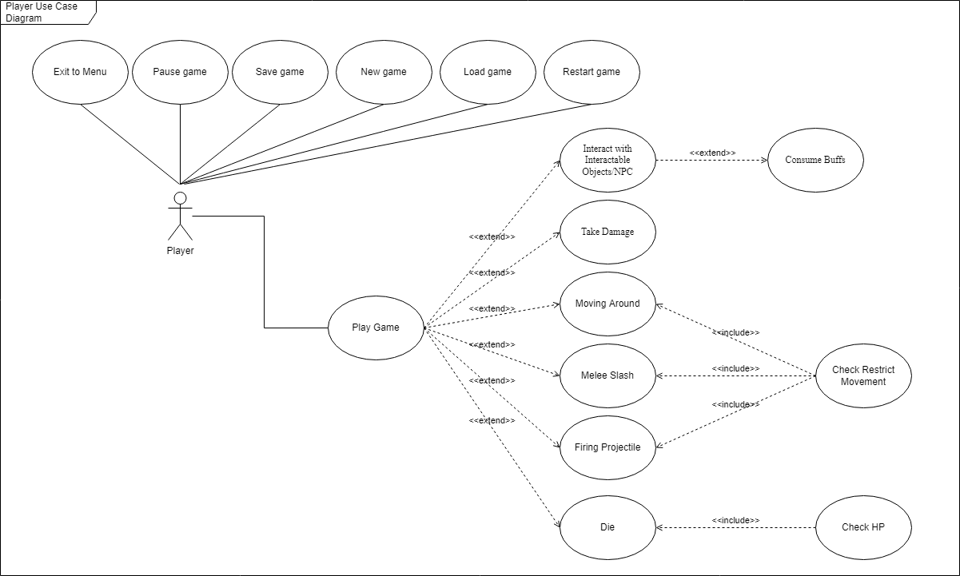

Image : Player Use Case Diagram

#### Slime

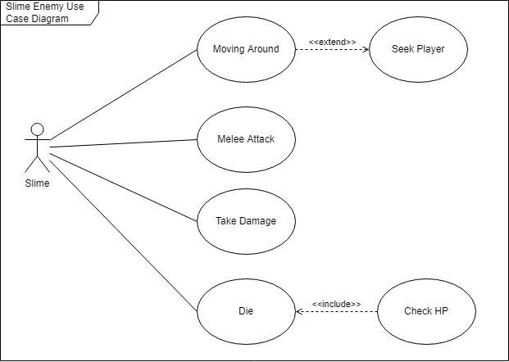

Image : Slime Use Case Diagram

#### Archer

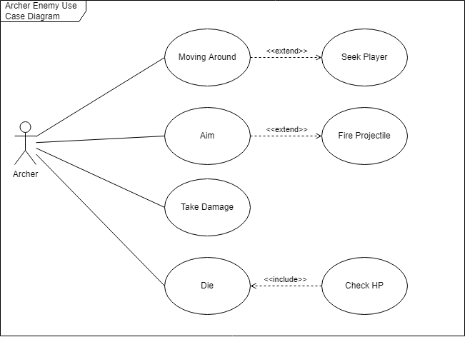

Image : Archer Use Case Diagram

#### Golem

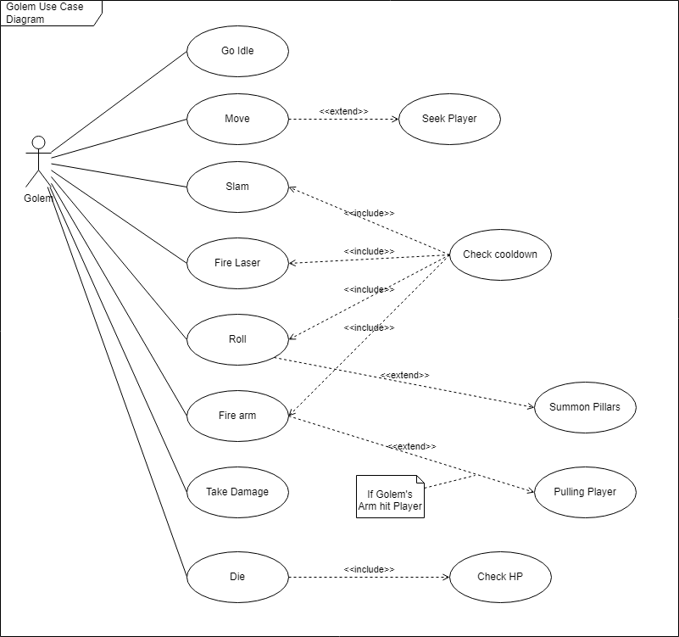

Image : Golem Use Case Diagram

#### ShopNPC

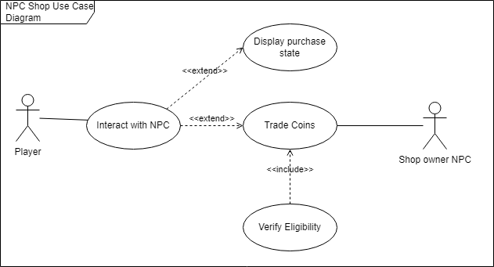

Image : Shope NPC Use Case Diagram

#### Shield Enemy

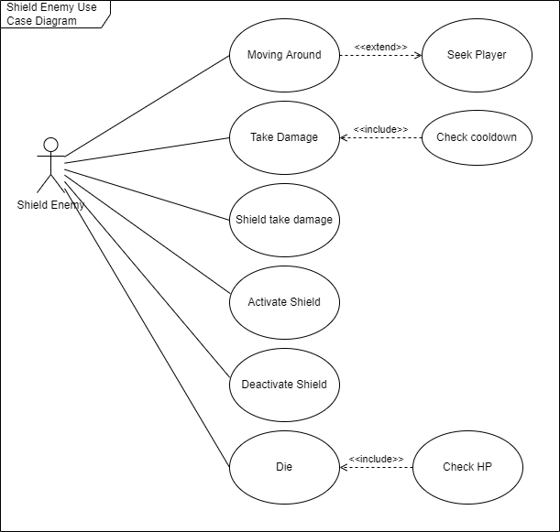

Image : Shield Enemy Use Case Diagram

#### Bomber

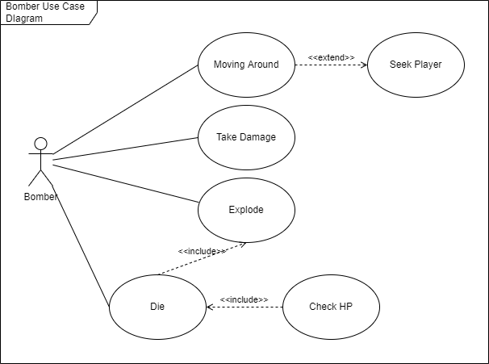

Image : Bomber Use Case Diagram

#### Audio Manager

Image : Audio Manager Use Case Diagram

#### Bringer Of Death Boss

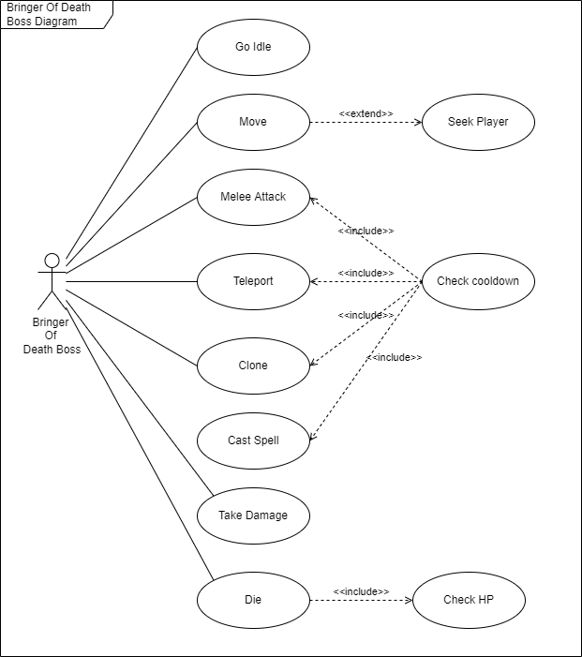

Image : Bringer of Death Boss Use Case Diagram

### Actor list

|  |  |  |
| --- | --- | --- |
| No. | Actor's name | Brief description / notes |
| 1 | Player | Is the person who's currently playing the game. PLayer can shoot, melee slash, dash, moving around the instance, collect coins, drink health potion, consume buffs and so on |
| 2 | Slime | Is a melee type enemy that swarms and attacks player. Has high hp and medium speed |
| 3 | Archer | Range type enemy that shoots projectile at player. Projectiles can freeze and restrict player movement and action. Has moderate hp and low movement speed |
| 4 | Golem | Boss type enemy that deals % max hp damage to player. Can slam, pull player toward it, fire laser, summon pillars, rolling around. Has hight hp, moderate speed and very high damage, it also drop a lot of coins when killed |
| 5 | ShopNPC | exchange coins for slots upgrade to player. Slots give player random quirks depending on the number of slots |
| 6 | Shield Enemy | Is a melee type enemy that can activate its shield to absorb damage and deal extra damage when its shield is up. They’re dangerous up close but they have low speed and mobility so they can be neutralized at range |
| 7 | Bomber | Is a memlee type enemy but rather than melee attacking they deal damage to the player by exploding if get close to player or when their healthpoint reach below 0. They’re very fast and can deal a lot of damage to player if the player is in their blast radius |
| 8 | Bringer of Death Boss | Boss type enemy with fast attack and high speed. The Boss mechanic is simple but can be discruptive and confuse player with its clone. Bringer of Death Boss can cast skill that rain down to player deal a small amount of damage but can apply shock status effect make player take increase damage. Its melee attack is telegraph so player can easilty notice it and dodge in time. Its clone skill and teleport can disrupt player momentum and use that opportunity to strike player down |
| 9 | Audio Manager | Play, control and process the sound and soundtrack in the game |

### Use case list

|  |  |  |
| --- | --- | --- |
| No. | Use case name | Short description / note |
| 1 | Play game | The use case begins when player click the "Play" button and load a save file |
| 2 | Exit Menu | The use case begins when user presses quit button in the menu |
| 3 | Pause game | The use case begins when user pressed pause button |
| 4 | Save game | The use case begins when player successfully makes a trade with the NPC , enters an instance, returns to the hideout or return to the main menu screen |
| 5 | New game | The use case begins when user presses create button or load button but no saved file is found |
| 6 | Load game | The use case begins when user presses load button |
| 7 | Restart game | The use case begins when player returns to hideout |
| 8 | Interact with interactable objects/NPC | The use case begins when player is in range to interact and presses the interact button |
| 9 | Melee Slash | The use case begins when the user is not in the main menu screen and presses the melee slash button (right click) |
| 10 | Firing projectiles | The use case begins when the user is not in the main menu screen and presses the fire buttons. This use case also triggers when archer enemy type finished aiming |
| 11 | Consume buffs | The use case begins when player enter a new instance or interacts with a buff |
| 12 | Check restrict movement | The use case begins when the player are trying to move around or perform an action while affected by freezing status effect or being pull by golem arm |
| 13 | Check HP | The use case begins when the entity is instantiated and still active. This use case also stay active throughout the player active play time |
| 14 | Die | The use case begins when the player's character hp or monster's hp reaches 0 or below |
| 15 | Take damage | The use case begins when the player or monster takes damage |
| 16 | Moving around | The use case begins when the AI selects a destination for the entity to move to. It also begin when the user is not in the main menu screen and presses either the arrows button or wasd buttons. It's being used by player to move around the instance and used by monsters to get close to player to perform their attacks |
| 17 | Melee Attack | The use case begins when the player is in the enemy entity's attack range and the entity perform a melee attack toward the player direction |
| 18 | Seek Player | The use case begins in the process of selecting destination for the enemy entity to lead to player current position. This use case is active throughout the life duration of an enemy |
| 19 | Go idle | The use case begins when golem need to switching state, phase or changing up an attack. When active all other golem actions stop. |
| 20 | Slam | The use case begins when golem is in its first stage, after it has done the fire arm action |
| 21 | Fire laser | The use case begins when the fire laser isn't on cooldown and the laser has finished summoning pillars |
| 22 | Roll | The use case begins when roll isn't on cooldown |
| 23 | Fire arm | The use case begins when firing arm isn't on cool down |
| 24 | Check Cooldown | The use case begins when golem perform any actions pertaining cooldown |
| 25 | Summon Pillars | The use case begins when golem has finished rolling |
| 26 | Pulling player | The use case begins when golem has fired its arm and it hits the player |
| 27 | Aim | The use case begins when the player is in range of any monster that can fire a projectile |
| 28 | Interact with NPC | The use case begins when the player is in the range to interact and presses the interact button |
| 29 | Display purchase state | The use case begins when the player chooses a buy option or in the transition from the first to the second dialogue |
| 30 | Trade coins | The use case begins when the player has interacted with the NPC |
| 31 | Verify Eligibility | The use case begins when the player has chosen a buy option |
| 32 | Explode | The use case begins when the bomber enemy get close enough to the player to explode |
| 33 | Shield Take Damage | The use case begins when the Shield Enemy type activate their shield and they got hit with a projectile or melee attack. The shield will take the damage instead of the Shield Enemy |
| 34 | Activate Shield | The use case begins when the Shield Enemy type has its shield come off cooldown |
| 36 | Deactivate Shield | The use case begins when the Shield Enemy’s Shield got its hp below 0 |
| 36 | Teleport | The use case begins when the Bringer of Death Boss teleport skill is off cooldown |
| 37 | Clone | The use case begins when the Bringer of Death Boss clone skill is off cooldown |
| 38 | Cast Spell | The use case begins when the Bringer of Death Boss spell skill is off cooldown |
| 39 | Play Sound | The use case begins whenever an object wants to play a sound effect |
| 40 | Play Soundtrack | The use case begins whenever a soundtrack need to be played in a scene |
| 41 | Remove Sound | The use case begins when an object that container game object of sound or soundtrack need to be destroy to remove the sound from playing |
| 42 | Fade Soundtrack | The use case begins when there is a need to fadeout current soundtrack and play another soundtrack if specified |
| 43 | Get Audio Clip | The use case begins whenever a sound effect or soundtrack need to be played so it can get the sound effect or sountrack needed from a list |
| 44 | Check Sound Availability | The use case begins whenever a sound effect or soundtrack need to be played. It’s used to check if the sound effect or soundtrack is available or not |

### Use case specification

#### Play game

|  |  |  |
| --- | --- | --- |
| **Short description** | | The use case begin when player click the "Play" button and load a save file |
| **Flow of events** | **Basic flow** | 1. Player click “Play” button in the main menu 2. Player load or create a new save file 3. Player enter the hideout and enter to an instance by interacting with the portal |
| **Alternative flow** | none. |
| **Special requirements** | | none. |
| **Pre-condition** | | * The game is on |
| **Post-condition** | | * Player playing the game |
| **Extend Points** | | * Use case “Interact with Interactable Objects/NPC”: player interact with intractable things around them * Use case “Take Damage”: player take damage when hit * Use case “Moving Around”: player move around the instance or hideout * Use case “Melee Slash”: player slash at monsters and knock them back * Use case “Firing Projectiles”: player shoot out projectiles to kill monsters * Use case “Die”: player’s character die after reaching 0 hp |

#### Exit menu

|  |  |  |
| --- | --- | --- |
| **Short description** | | Player exit to main menu |
| **Flow of events** | **Basic flow** | 1. Player press esc key 2. A pop up appear 3. Player click the “exit to menu” button |
| **Alternative flow** | 3. Press the esc key again to close the pop up window |
| **Special requirements** | | none. |
| **Pre-condition** | | * Player is in hideout |
| **Post-condition** | | * Player get back to the main menu |
| **Extend Points** | | none. |

#### Pause game

|  |  |  |
| --- | --- | --- |
| **Short description** | | Player pause the game |
| **Flow of events** | **Basic flow** | 1. Player enter the game after clicking the play button in main menu 2. Player click “load” button on a save slot 3. Player press esc to pause the game 4. Press esc again to unpause the game |
| **Alternative flow** | none. |
| **Special requirements** | | none. |
| **Pre-condition** | | * Player is in an instance or in the hideout |
| **Post-condition** | | * The game is paused |
| **Extend Points** | | none. |

#### Save game

|  |  |  |
| --- | --- | --- |
| **Short description** | | The use case begins when player successfully makes a trade with the NPC , enters an instance, returns to the hideout or return to the main menu screen |
| **Flow of events** | **Basic flow** | 1. Player enter the game after clicking the play button in main menu 2. Player click “load” button on a save slot 3. Player enter an instance by interacting with the portal |
| **Alternative flow** | Alternative 1:  3. Player interact with the npc and buy a slot  Alternative 2:  3. Player enter an instance by interacting with the portal  4. Player retreat to hideout |
| **Special requirements** | | none. |
| **Pre-condition** | | * Player is in an instance or in the hideout * Player character isn’t dead |
| **Post-condition** | | * Player coins and slots are saved |
| **Extend Points** | | none. |

#### New game

|  |  |  |
| --- | --- | --- |
| **Short description** | | The use case begins when user presses create button or load button but no saved file is found |
| **Flow of events** | **Basic flow** | 1. Player enter the game after clicking the play button in main menu 2. Player click “load” button on a save slot |
| **Alternative flow** | 2. Player click “new“ button on a save slot. |
| **Special requirements** | | None. |
| **Pre-condition** | | * If click “load” button the save slot need to be empty |
| **Post-condition** | | * New game save file is created or overwritten (if click “new” button on an already exist save file) |
| **Extend Points** | | none. |

#### Load game

|  |  |  |
| --- | --- | --- |
| **Short description** | | The use case begins when user presses create button or load button but no saved file is found |
| **Flow of events** | **Basic flow** | 1. Player enter the game after clicking the play button in main menu 2. Player click “load” button on a save slot |
| **Alternative flow** | none. |
| **Special requirements** | | none. |
| **Pre-condition** | | none. |
| **Post-condition** | | * Load the save file player chosen |
| **Extend Points** | | none. |

#### Restart game

|  |  |  |
| --- | --- | --- |
| **Short description** | | The use case begins when player returns to hideout |
| **Flow of events** | **Basic flow** | 1. Player enter an instance by interacting with the portal 2. Player fight the monster but feel like they can’t continue 3. Player press esc key to pause the game and the pause menu appear 4. Player press the “Retreat to hideout” button 5. A pop up appear to warn player that they only keep 30% of the coins they found 6. Player click “yes” button 7. Player return to hideout |
| **Alternative flow** | 6. Player click “no” button  7. Return to the pause menu |
| **Special requirements** | | none. |
| **Pre-condition** | | * Player is in an instance |
| **Post-condition** | | * Player return to hideout and only keep 30% of the coins they earnt during the previous instance |
| **Extend Points** | | none. |

#### Interact with interactable objects/NPC

|  |  |  |
| --- | --- | --- |
| **Short description** | | The use case begins when player is in range to interact and presses the interact button |
| **Flow of events** | **Basic flow** | 1. Player enter the hideout 2. Player get close to the NPC or Interactable Object until an “E” key pressing animation appeared on top of player 3. Player press E and interact with the NPC or Interactable Object |
| **Alternative flow** | none. |
| **Special requirements** | | none. |
| **Pre-condition** | | * Player is close to the NPC or Interactable Object. |
| **Post-condition** | | * Player interact with the NPC or Interactable Object |
| **Extend Points** | | none. |

#### Melee Slash

|  |  |  |
| --- | --- | --- |
| **Short description** | | The use case begins when the user is not in the main menu screen and presses the melee slash button |
| **Flow of events** | **Basic flow** | 1. Player enter an instance and start playing the game 2. An enemy get close to the player 3. Player right click to perform a melee slash attack 4. The monster is knockback |
| **Alternative flow** | none. |
| **Special requirements** | | none. |
| **Pre-condition** | | * Player movement and action are not restricted |
| **Post-condition** | | * Monsters in player melee slash range are knock back |
| **Extend Points** | | none. |

#### Firing projectiles

|  |  |  |
| --- | --- | --- |
| **Short description** | | The use case begins when the user is not in the main menu screen and presses the fire buttons. This use case also trigger when archer enemy type finished aiming |
| **Flow of events** | **Basic flow** | 1. Player enter an instance and start playing the game 2. Player see monsters and left click to fire projectile at their current cursor position 3. Projectile coming out from player’s character gun barrel |
| **Alternative flow** | none. |
| **Special requirements** | | none. |
| **Pre-condition** | | * Player movement and action are not restricted |
| **Post-condition** | | * A Projectile shoot out from player barrel |
| **Extend Points** | | none. |

#### Consume buffs

|  |  |  |
| --- | --- | --- |
| **Short description** | | The use case begins when player enter a new instance or interacts with a buff |
| **Flow of events** | **Basic flow** | 1. Player enter an instance and start playing the game 2. After clearing a room a random buff spawn depending on their weight 3. Player get close to the buff until the interact icon show up 4. Player press the interact key and consume the buff 5. The buff disappear and apply its buff to player stats |
| **Alternative flow** | none. |
| **Special requirements** | | none. |
| **Pre-condition** | | * Player movement and action are not restricted * Player are near the buff enough so that the interact icon show up |
| **Post-condition** | | * The buff disappear and it apply the buff to the player |
| **Extend Points** | | none. |

#### Check restrict movement

|  |  |  |
| --- | --- | --- |
| **Short description** | | The use case begins when the player has pressed a combination of move buttons |
| **Flow of events** | **Basic flow** | 1. Player enter an instance and start playing the game 2. Player get hit by either an Archer’s projectiles and getting freeze or getting pull by golem arm 3. Player try different inputs but nothing go through 4. After restrict movement is lifted player can move and perform action again |
| **Alternative flow** | none. |
| **Special requirements** | | none. |
| **Pre-condition** | | * Player movement and action are not already restricted |
| **Post-condition** | | * Player can’t move or perform action |
| **Extend Points** | | none. |

#### Check HP

|  |  |  |
| --- | --- | --- |
| **Short description** | | The use case begins when the entity is instantiated and still active. This use case also stay active throughout the player active play time |
| **Flow of events** | **Basic flow** | 1. An entity is instantiated 2. During the entity active time check entity health points every interval using either Update of FixedUpdate function from Unity |
| **Alternative flow** | Entity is a golem:   1. Golem hp are below a certain threshold 2. Switch state or phase depending on the threshold condition   Entity’s hp are lower or equal to 0  3. Switch entity animation to die animation  4. Destroy the gameobject that represent the entity |
| **Special requirements** | | None. |
| **Pre-condition** | | * Entity is instantiated and active |
| **Post-condition** | | None. |
| **Extend Points** | | None. |

#### Die

|  |  |  |
| --- | --- | --- |
| **Short description** | | The use case begins when the player's character hp or monster's hp reaches 0 or below. It run the player’s character die animation or monster’s die animation if there are any then destroy the game object that represent either player’s character or monster |
| **Flow of events** | **Basic flow** | 1. Player’s character or monster’s hp reach 0 2. Play the respective dying animation for the player’s character or monster 3. Destroy the game object that represent player’s character or monster at the end of the animation |
| **Alternative flow** | None. |
| **Special requirements** | | None. |
| **Pre-condition** | | * Player’s character hp or monster’s hp reach 0. |
| **Post-condition** | | * Destroy game object that represent the entity that reach 0 hp |
| **Extend Points** | | None. |

#### Take damage

|  |  |  |
| --- | --- | --- |
| **Short description** | | The use case begins when the player or monster takes damage |
| **Flow of events** | **Basic flow** | 1. Entity's rigid body detect a collision from the player’s attack 2. Entity's health point is reduced according to damage inflicted |
| **Alternative flow** | None. |
| **Special requirements** | | None. |
| **Pre-condition** | | * Entity is alive and active |
| **Post-condition** | | * Entity hp are reduce according to the damage taken and reacts to it accordingly |
| **Extend Points** | | None. |

#### Moving around

|  |  |  |
| --- | --- | --- |
| **Short description** | | Entity moves around the instance |
| **Flow of events** | **Basic flow** | 1. Entity checks the distance from its standing point to player 2. Entity moves toward the player 3. Entity run animation activates |
| **Alternative flow** | Player isn’t in Entity's range   1. Entity checks the distance from its standing point to player 2. Entity moves to a random destination 3. Entity's run animation activates   If Entity is player   1. Detect directional input from player 2. Move the player’s character according to player movement speed 3. Run the running animation for player’s character |
| **Special requirements** | | None. |
| **Pre-condition** | | * Entity is alive and active * If Entity is player then player’s character doesn’t affected by any kind restrict movement |
| **Post-condition** | | * Entity's velocity is larger than 0 |
| **Extend Points** | | None. |

#### Melee Attack

|  |  |  |
| --- | --- | --- |
| **Short description** | | When the player is in a melee type enemy attack range that enemy perform a melee attack |
| **Flow of events** | **Basic flow** | 1. Entity's attack animation activates 2. Increase the size of its collider 3. Player takes damages 4. Return the size of its collider to normal |
| **Alternative flow** | The attack doesn’t hit player   1. Entity's attack animation activates 2. Increase the size of its collider 3. return the size of its collider to normal |
| **Special requirements** | | None. |
| **Pre-condition** | | * Entity is alive and active |
| **Post-condition** | | * Entity perform a melee attack. |
| **Extend Points** | | None. |

#### Seek Player

|  |  |  |
| --- | --- | --- |
| **Short description** | | The process of finding a path from one to the player |
| **Flow of events** | **Basic flow** | 1. Register the position of the entity and the player 2. find the shortest path from the entity to the player without clashing with other objects |
| **Alternative flow** | None. |
| **Special requirements** | | * A* pathfinding algorithm |
| **Pre-condition** | | * The entity and the player must be in the same scene, and is alive and active |
| **Post-condition** | | None. |
| **Extend Points** | | None. |

#### Go idle

|  |  |  |
| --- | --- | --- |
| **Short description** | | Entity changes its state to idle |
| **Flow of events** | **Basic flow** | 1. Entity can’t do any other action 2. Entity changes its state to idle 3. Activate Entity's idle animation |
| **Alternative flow** | None. |
| **Special requirements** | | None. |
| **Pre-condition** | | * Entity is still alive and active; * Golem is in its first stage or in its second stage and is in post firing arm actions and slam action( for golem only) |
| **Post-condition** | | None. |
| **Extend Points** | | None. |

#### Slam

|  |  |  |
| --- | --- | --- |
| **Short description** | | Slam attack perform by Golem Boss |
| **Flow of events** | **Basic flow** | 1. Golem’s slam animation activates 2. Instantiate slam effect |
| **Alternative flow** | Golem is too far from the player ( only in fist stage)   1. golem checks the distance from its standing point to player 2. Golem moves toward player |
| **Special requirements** | | None. |
| **Pre-condition** | | * Golem is alive ,active and the slam action isn’t on cooldown |
| **Post-condition** | | None. |
| **Extend Points** | | None. |

#### Fire laser

|  |  |  |
| --- | --- | --- |
| **Short description** | | Golem stays still and shoot a laser beam sweeping from right to left |
| **Flow of events** | **Basic flow** | 1. Golem’s laser animation activates 2. Instantiate laser object 3. laser start from the right side of the golem and move toward the left side 4. halt a bit upon reaching the left side and come back to the right side 5. deactivate the laser object when the beam has reached the right side |
| **Alternative flow** | None. |
| **Special requirements** | | None. |
| **Pre-condition** | | * Golem is in 2nd phase ,still active ,the laser action isn’t on cooldown and * The has already summoned pillars |
| **Post-condition** | | None. |
| **Extend Points** | | None. |

#### Roll

|  |  |  |
| --- | --- | --- |
| **Short description** | | Golem rolls |
| **Flow of events** | **Basic flow** | 1. golem’s fold animation activates 2. Golem speed is increased 3. Golem moves to all waypoints 4. Golem’s unfold animation activate 5. Golem speed returns to its base |
| **Alternative flow** | None. |
| **Special requirements** | | None. |
| **Pre-condition** | | * Golem is alive ,active , in its 2nd phase and the roll action isn’t on cooldown |
| **Post-condition** | | None. |
| **Extend Points** | | None. |

#### Fire arm

|  |  |  |
| --- | --- | --- |
| **Short description** | | Golem Fire its arm at Player pulling Player toward its position then proceed to slam the Player |
| **Flow of events** | **Basic flow** | 1. golem fires its arm to pull the player back to its position 2. pull the player back to the golem 3. Golem’s slam animation activates 4. Instantiate slam effect |
| **Alternative flow** | None. |
| **Special requirements** | | None. |
| **Pre-condition** | | * Golem is alive and active * Golem is in its second phase * Fire arm isn’t on cooldown |
| **Post-condition** | | * Golem’s arm shoot out toward the player at high speed. |
| **Extend Points** | | Use case “Pulling player”. |

#### Check Cooldown

|  |  |  |
| --- | --- | --- |
| **Short description** | | Check the cooldown of an action and return a flag indicating if if it is still on cooldown or not |
| **Flow of events** | **Basic flow** | 1. Start cooldown timer 2. return the flag 3. Reset the timer |
| **Alternative flow** | None. |
| **Special requirements** | | None. |
| **Pre-condition** | | * There is a skill on cooldown. |
| **Post-condition** | | * Return the cooldown state of that skill. |
| **Extend Points** | | None. |

#### Summon Pillars

|  |  |  |
| --- | --- | --- |
| **Short description** | | Golem stays still and summons a set a pillar |
| **Flow of events** | **Basic flow** | 1. Activate summon animation 2. instantiate pillars for each waypoint there are in the arena |
| **Alternative flow** | None. |
| **Special requirements** | | None. |
| **Pre-condition** | | * Golem is in 2nd phase ,still active. * Has already done the rolled action |
| **Post-condition** | | * Pillars are summoned from the ground for player to hide behind |
| **Extend Points** | | None. |

#### Pulling player

|  |  |  |
| --- | --- | --- |
| **Short description** | | The arm that the golem shoots out and grab the player back to near the golem |
| **Flow of events** | **Basic flow** | 1. Golem fire out its arm 2. The arm hit player 3. move the player position next to the golem |
| **Alternative flow** | None. |
| **Special requirements** | | None. |
| **Pre-condition** | | * The Golem has shot its arm and it hits the player |
| **Post-condition** | | * Player are pulled toward golem’s position |
| **Extend Points** | | None. |

#### Aim

|  |  |  |
| --- | --- | --- |
| **Short description** | | Archer aims |
| **Flow of events** | **Basic flow** | 1. Archer aim animation activates 2. Archer stay still and calculate the fire direction 3. Archer fires projectiles |
| **Alternative flow** | None. |
| **Special requirements** | | None. |
| **Pre-condition** | | * Archer is alive and active * Player is in archer’s attack range |
| **Post-condition** | | * A projectile shoot out from Archer. |
| **Extend Points** | | None. |

#### Interact with NPC

|  |  |  |
| --- | --- | --- |
| **Short description** | | Player interacts with the NPC |
| **Flow of events** | **Basic flow** | 1. Player presses interact button |
| **Alternative flow** | None. |
| **Special requirements** | | None. |
| **Pre-condition** | | * Player is active * The player is in the range to interact * The object the player interacts with must be interactable |
| **Post-condition** | | None. |
| **Extend Points** | | Use case “Display purchase state”.  Use case “Trade coins” |

#### Display purchase state

|  |  |  |
| --- | --- | --- |
| **Short description** | | This use-case is used for the shop owner NPC to show the buy options to the player |
| **Flow of events** | **Basic flow** | 1. Player interacts with the shop owner to buy unlockable slot 2. The shop owner NPC checks if player can still buy more unlockable slots 3. The shop owner shows the player buy options 4. The shop owner shows if the trade is success or not |
| **Alternative flow** | Player has reached the maximum number of slot that can be unlocked  3. The shop owner alerts the player to not buy more unlockable slots. |
| **Special requirements** | | None. |
| **Pre-condition** | | * Player is active * The number of player’s current unlockable slots isn’t negative |
| **Post-condition** | | * Display NPC Shop UI and dialogue. |
| **Extend Points** | | None. |

#### Trade coins

|  |  |  |
| --- | --- | --- |
| **Short description** | | Player trade in the coin for unlockable slots |
| **Flow of events** | **Basic flow** | 1. Player chooses a buy option 2. Player’s coin is reduced 3. Player unlocks new slot |
| **Alternative flow** | None. |
| **Special requirements** | | None. |
| **Pre-condition** | | * Player meet the eligibility criteria |
| **Post-condition** | | * Player’s coin is reduced accordingly to the purchase * Player unlock a slot |
| **Extend Points** | | None. |

#### Verify Eligibility

|  |  |  |
| --- | --- | --- |
| **Short description** | | This use-case is used for the shop owner NPC to check if the player can buy or not |
| **Flow of events** | **Basic flow** | 1. Player interacts with the shop owner to buy unlockable slot 2. The shop owner NPC show options to the player 3. The player chooses the available option 4. The shop owner NPC checks if the player has enough coins or already maxed out slots 5. The shop owner notify user on their eligibility |
| **Alternative flow** | None. |
| **Special requirements** | | None. |
| **Pre-condition** | | * Player interact with the ShopNPC |
| **Post-condition** | | * Return player eligibility. |
| **Extend Points** | | None. |

#### Explode

|  |  |  |
| --- | --- | --- |
| **Short description** | | This use-case is used for the Bomber enemy so they can explode and deal massive daamge to player if the player is in the blast radius |
| **Flow of events** | **Basic flow** | 1. Player gets close to the range of attack of Bomber enemy or Bomber enemy is dying 2. Bomber enemy plays the explode animation 3. Bomber enemy explode and create a fire explosion 4. Player is caught in the explosion and take big damage |
| **Alternative flow** | 4. Player is not in the explosion radius and take no damage |
| **Special requirements** | | * None |
| **Pre-condition** | | * Bomber enemy is dying or player in range of Bomber enemy attack |
| **Post-condition** | | * Player takes damage if in the blast radius * Player doesn’t take damage if not caught in the blast radius |
| **Extend Points** | |  |

#### Shield Take Damage

|  |  |  |
| --- | --- | --- |
| **Short description** | | This use-case is used for the Shield Enemy so their shield can take the damage instead |
| **Flow of events** | **Basic flow** | 1. Shield Enemy activate its shield 2. The Shield Enemy got hit by an attack 3. The Shield Enemy’s shield health point is reduced by the amount of damage taken |
| **Alternative flow** | None |
| **Special requirements** | | * None |
| **Pre-condition** | | * Shield Enemy Activate their shield * Shield Enemy is hit by an attack |
| **Post-condition** | | * Shield Enemy’s shield health point is reduce by the amount of damage taken |
| **Extend Points** | | None. |

#### Activate Shield

|  |  |  |
| --- | --- | --- |
| **Short description** | | This use-scase is used by Shield Enemy to activate their shield |
| **Flow of events** | **Basic flow** | 1. Shield Enemy’s shield is off cooldown 2. Shield Enemy Activate their shield 3. Shield Enemy’s shield is up and Shield Enemy get increased damage and protection from damage whe their shield is up |
| **Alternative flow** | None. |
| **Special requirements** | | * None. |
| **Pre-condition** | | * Shield Enemy’s shield is off cooldown |
| **Post-condition** | | * Shield Enemy’s shield is activated |
| **Extend Points** | | None. |

#### Deactivate Shield

|  |  |  |
| --- | --- | --- |
| **Short description** | | This use-case is ued by the Shield Enemy to deactivate their shield when their shield health point is equal or below 0 |
| **Flow of events** | **Basic flow** | 1. Shield Enemy’s shield got damage and its health point is below 0 2. Shield Enemy’s shield get deactivated 3. Shield Enemy lost protection from damage and damage increase |
| **Alternative flow** | None. |
| **Special requirements** | | * None. |
| **Pre-condition** | | * Shield Enemy’s shield health point is equal or below 0 |
| **Post-condition** | | * Shield Enemy’s shield is deactivated and go on cooldown |
| **Extend Points** | | None. |

#### Teleport

|  |  |  |
| --- | --- | --- |
| **Short description** | | This use-case is used by the Bringer of Death Boss to teleport to player position with an offset depend on the Boss width and height |
| **Flow of events** | **Basic flow** | 1. Bringer of Death Boss’s teleport skill is off cooldown 2. Bringer of Death Boss cast the teleport skill 3. Bringer of Death Boss is invulnerable and go in its portal 4. Bringer of Death Boss re-appear at the player position |
| **Alternative flow** | None. |
| **Special requirements** | | * None. |
| **Pre-condition** | | * Bringer of Death Boss’s teleport skill is off cooldown |
| **Post-condition** | | * Brginer of Death Boss is teleported to the player position |
| **Extend Points** | | None. |

#### Clone

|  |  |  |
| --- | --- | --- |
| **Short description** | | This use-case is used by the Bringer of Death Boss to clone itself and to discrupt player |
| **Flow of events** | **Basic flow** | 1. Bringer of Death Boss’s clone skill is off cooldown 2. Bringer of Death Boss cast the clone skill 3. Four Bringer of Death Boss clones appear at player position and melee attack player 4. Bringer of Death Clone die after a certain amount of time |
| **Alternative flow** | None. |
| **Special requirements** | | * Bringer of Death clones need to die after amount of time |
| **Pre-condition** | | * Bringer of Death’s clone skill is off cooldown |
| **Post-condition** | | * Bringer of Death clones itself |
| **Extend Points** | | None. |

#### Cast Spell

|  |  |  |
| --- | --- | --- |
| **Short description** | | This use-case is used by Bringer of Death Boss to rain down spell attack on player |
| **Flow of events** | **Basic flow** | 1. Bringer of Death Boss’s spell skill is off cooldown 2. Bringer of Death Boss cast the spell skill 3. Portals appear on top the head of player and rain down attack |
| **Alternative flow** | None. |
| **Special requirements** | | None. |
| **Pre-condition** | | * Bringer of Death’s spell is off cooldown |
| **Post-condition** | | * Bringer of Death’s spells rain down and attack player |
| **Extend Points** | | None. |

#### Play Sound

|  |  |  |
| --- | --- | --- |
| **Short description** | | This use-case is used by Audio Manager to play sound effect |
| **Flow of events** | **Basic flow** | 1. A game object calls the play sound function from the Audio Manager instance 2. Audio Manager find the sound needed to play 3. Audio Manager play the sound |
| **Alternative flow** | 3. Audio Manager can’t find the sound  4. Audio Manager display an error message saying specific  sound is not available or missing |
| **Special requirements** | | None. |
| **Pre-condition** | | * Audio manager can find the sound needed to play |
| **Post-condition** | | * A sound is played by the Audio Manager instance |
| **Extend Points** | | None |

#### Play Soundtrack

|  |  |  |
| --- | --- | --- |
| **Short description** | | This use-case is used by Audio Manager to play soundtrack |
| **Flow of events** | **Basic flow** | 1. A game object calls the play sountrack function from the Audio Manager instance 2. Audio Manager find the soundtrack needed to play 3. Audio Manager play the soundtrack |
| **Alternative flow** | 3. Audio Manager can’t find the sound  4. Audio Manager display an error message saying specific  soundtrack is not available or missing |
| **Special requirements** | | None. |
| **Pre-condition** | | * Audio manager can find the soundtrack needed to play |
| **Post-condition** | | * A soundtrack is played by the Audio Manager instance |
| **Extend Points** | | None. |

#### Remove Sound

|  |  |  |
| --- | --- | --- |
| **Short description** | | This use-case is used by the Audio Manager to remove a specific game object container of a sound and stop it from playing |
| **Flow of events** | **Basic flow** | 1. Audio Manager find the object with the sound needed to be removed 2. Audio Manager remove the game object that contain the specific sound |
| **Alternative flow** | 2. Audio Manager can’t find the game object that contain that need to be removed  3. Audio manager stop the function |
| **Special requirements** | | None. |
| **Pre-condition** | | * The sound needed to be removed is found |
| **Post-condition** | | * The game object that contains specific sound that needed to be removed is destroyed |
| **Extend Points** | | None. |

#### Fade Soundtrack

|  |  |  |
| --- | --- | --- |
| **Short description** | | This use-case is used by Audio Manager to fade out the current soundtrack and play another soundtrack if specified |
| **Flow of events** | **Basic flow** | 1. Audio Manager find current playing soundtrack 2. Audio Manager fade out the soundtrack over time until the soundtrack volume reach 0 |
| **Alternative flow** | 1. Audio Manager play another soundtrack |
| **Special requirements** | | None. |
| **Pre-condition** | | * None. |
| **Post-condition** | | * Current soundtrack is fade out and new soundtrack is played if specified |
| **Extend Points** | | None. |

#### Get Audio Clip

|  |  |  |
| --- | --- | --- |
| **Short description** | | This use-case is used by Audio Manager to get specific audio clip to play it |
| **Flow of events** | **Basic flow** | 1. Audio Manager find the needed audio clip to play 2. Audio Manager the audio clip and assign it to a game object to play the sound |
| **Alternative flow** | 2. The Audio Manager can’t find the audio clip  3. The Audio Manager display an error saying the specified audio clip cannot be found |
| **Special requirements** | | None. |
| **Pre-condition** | | * Audio Clip is found by Audio Manager |
| **Post-condition** | | * Audio Manager get the audio clip and process it |
| **Extend Points** | | None. |

#### Check Sound Availability

|  |  |  |
| --- | --- | --- |
| **Short description** | | This use-case is used by Audio Manager to check if a sound is available to play |
| **Flow of events** | **Basic flow** | 1. Audio Manager find the audio clip 2. Audio Manager check the audio clip 3. Return the availability of the specified audio clip |
| **Alternative flow** | None. |
| **Special requirements** | | None. |
| **Pre-condition** | | * None. |
| **Post-condition** | | * Availability of specified audio clip |
| **Extend Points** | | None. |

# CHAPTER III: ANALYSIS DESIGN

## Classes Analysis

### Class diagrams

#### Player and Enemy class Diagram

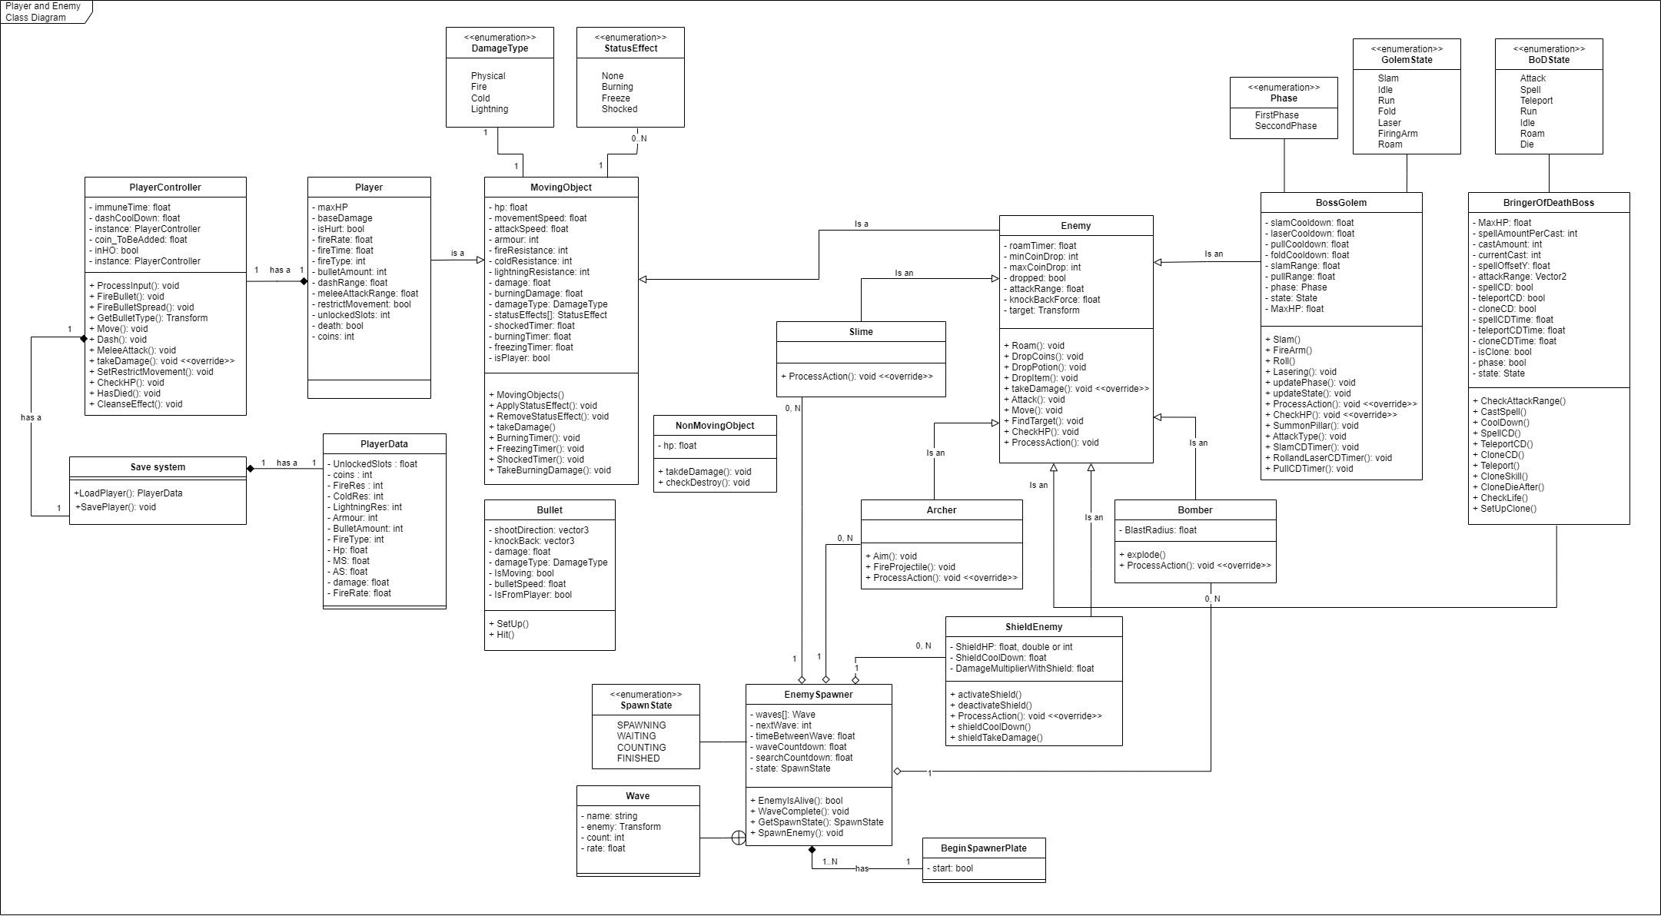

Image : Player and Enemies Class Diagram

#### Interactable Class Diagram

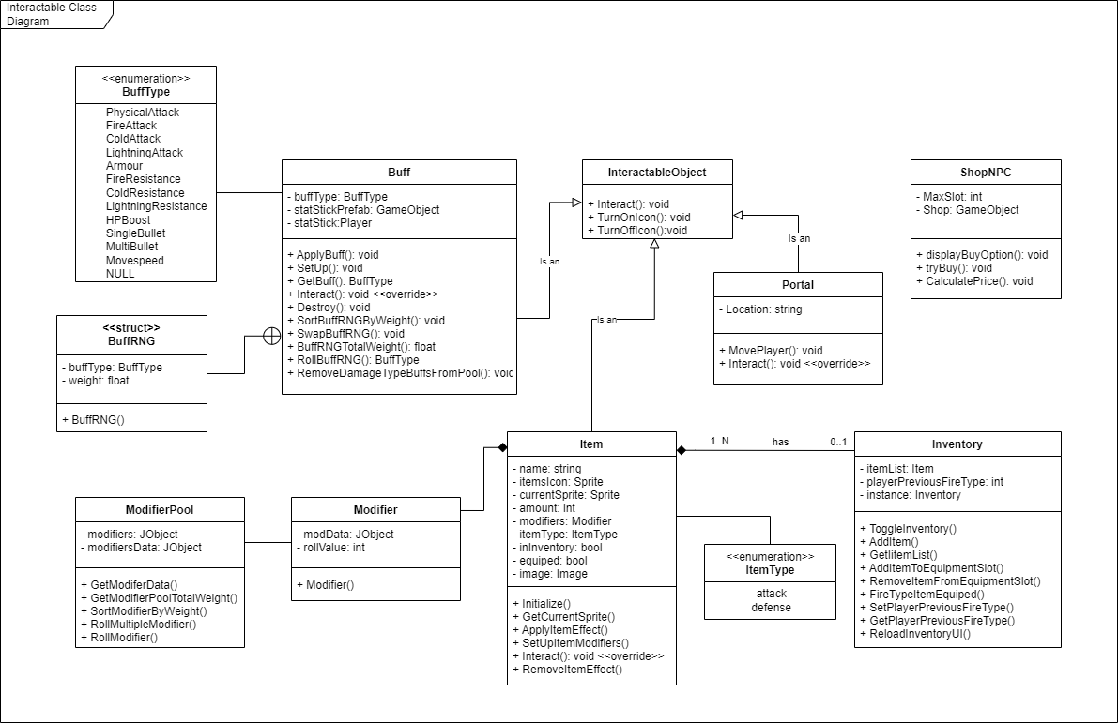

Image : Interactable Class Diagram

#### Menu and Managers Class Diagram

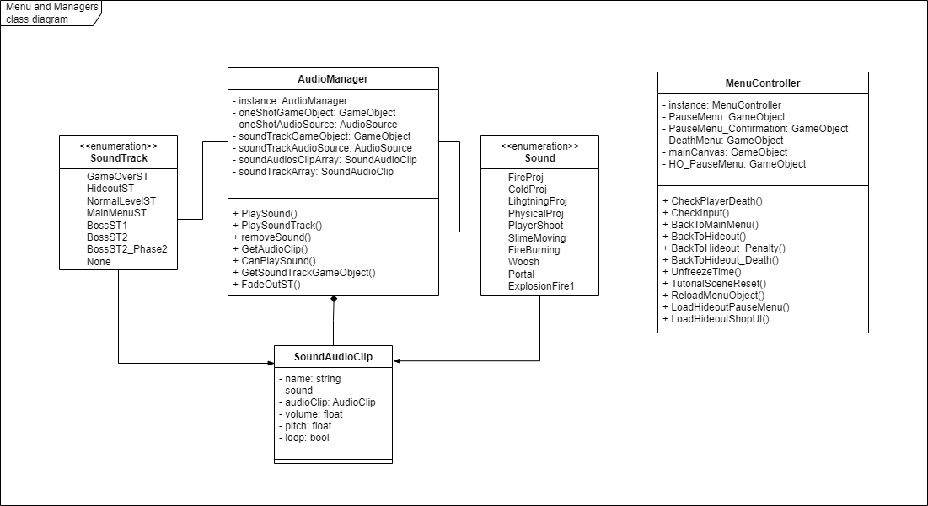

Image : Menu and Managers Class Diagram

### List of classes and relationships

#### Classes

|  |  |  |  |
| --- | --- | --- | --- |
| No. | Class Name | Type | Note |
| 1 | MovingObject | Normal Class | Every moving Player and Enemy parent class |
| 2 | DamageType | Enum | Damage type every Moving Object has |
| 3 | StatusEffect | Enum | Status effect that affect every Moving Object |
| 4 | Player | Normal Class | Player class |
| 5 | PlayerController | Normal Class | Controller for player class, processing player input and action |
| 6 | Player Data | Normal Class | Use to save player data to a save file |
| 7 | Save system | Normal Class | Save system |
| 8 | NonMovingObject | Normal Class | Any Object that don't perform an action in the game |
| 9 | Enemy | Normal Class | Parent class for enemy type |
| 10 | Slime | Normal Class | Melee enemy type |
| 11 | Archer | Normal Class | Range enemy type |
| 12 | BossGolem | Normal Class | Boss enemy type |
| 13 | Phase | Enum | Phase golem use to perform attacks |
| 14 | State | Enum | State golem use to change animation and process next action |
| 15 | EnemySpawner | Normal Class | Spawn enemy in an instance |
| 16 | BeginSpawnerPlate | Normal Class | Use to trigger spawner to spawn enemies |
| 17 | SpawnState | Enum | Spawner state to know which state the spawner currently in i.e., SPAWNING, FINISHED... |
| 18 | Wave | Normal Class | Hold the information about an enemy type, the amount, and rate to spawn them |
| 19 | Bullet | Normal Class | Use by all projectile types in the game |
| 20 | InteractableObject | Normal Class | Object that player can interact with |
| 21 | Portal | Normal Class | Use to transition player from one scene to another |
| 22 | Buff | Normal Class | Buff use to enhance player stats and ability |
| 23 | BuffType | Enum | Use to differentiate between the buff |
| 24 | BuffRNG | Struct | Use to spawn/apply random buff(s) after player cleared a room or enter an instance |
| 25 | ShopNPC | Normal Class | Control ShopNPC behaviour in game |
| 26 | Item | Normal Class | Control the item behavior in the game |
| 27 | ItemType | Enum | Item type to know which modifier pool to get the modifiers for the item |
| 28 | Inventory | Normal Class | Control the behavior of the player inventory in the game |
| 29 | Modifier | Normal Class | Hold the modifer data for the item |
| 30 | ModifierPool | Normal Class | Use to get random modifier from a pool of modifiers depend on the item type of the pool |
| 31 | ShieldEnemy | Normal Class | Shield Enemy type |
| 32 | Bomber | Normal Class | Suicide Enemy type |
| 33 | BringerOfDeathBoss | Normal Class | Boss enemy type |
| 34 | BoDState | Enum | State Bringer of Death use to control its behaviors |
| 35 | AudioManager | Normal Class | Control all the sound effect and soundtrack in the game |
| 36 | Sound | Enum | Sound enumerable to know which sound to play |
| 37 | SoundTrack | Enum | Soundtrack enumerable to know which soundtrack to play |
| 38 | SoundAudioClip | Normal Class | Control the audio source properties like volumn, pitch, loop, etc that being played by the AudioManager |
| 39 | MenuController | Normal Class | Control the menu of the game |

#### Relationships

|  |  |  |  |
| --- | --- | --- | --- |
| No. | Class Relationship | Relationship type | Note |
| 1 | MovingObject - DamageType | Association relationship | Relationship: (1) - (1) |
| 2 | MovingObject - StatusEffect | Association relationship | Relationship: (1) - (0..N) |
| 3 | Player - MovingObject | Inheritance relationship | Verb: "is"  Relationship: (1) - (1) |
| 4 | PlayerController - Player | Composition relationship | Verb: "has"  Relationship: (1) - (1) |
| 5 | Save System | Composition relationship | Verb: "has"  Relationship: (1) - (1) |
| 6 | PlayerData | Composition relationship | Verb: "has"  Relationship: (1) - (1) |
| 7 | Enemy - Moving Object | Inheritance relationship | Verb: "is" |
| 8 | Slime - Enemy | Inheritance relationship | Verb: "is" |
| 9 | Archer - Enemy | Inheritance relationship | Verb: "is" |
| 10 | Golem - Enemy | Inheritance relationship | Verb: "is" |
| 11 | Phase - Golem | Association relationship | None |
| 12 | GolemState - Golem | Association relationship | None |
| 13 | EnemySpawner - Slime | Aggregation relationship | Relationship: (1) - (0..N) |
| 14 | EnemySpawner - Archer | Aggregation relationship | Relationship: (1) - (0..N) |
| 15 | EnemySpawner - Wave | Association relationship | Wave is a subclass inside EnemySpanwer |
| 16 | EnemySpawner - SpawnState | Association relationship | None |
| 17 | BeginSpawnerPlate - EnemySpawner | Composition relationship | Verb: "has"  Relationship: (1) - (1..N) |
| 18 | Portal - InteractableObject | Inheritance relationship | Verb: "is" |
| 19 | Buff - InteractableObject | Inheritance relationship | Verb: "is" |
| 20 | BuffType - Buff | Association relationship | None |
| 21 | BuffRNG - Buff | Association relationship | BuffRNG is a subclass inside Buff |
| 22 | ShieldEnemy - Enemy | Inheritance relationship | Verb: "is" |
| 23 | Bomber - Enemy | Inheritance relationship | Verb: "is" |
| 24 | BringerOfDeathBoss - Enemy | Inheritance relationship | Verb: "is" |
| 25 | Item - Modifier | Composition relationship | None |
| 26 | ModifierPool – Modifier | Association relationship | None |
| 27 | Inventory – Item | Composition relationship | Verb: "has"  Relationship: (1) - (1..N) |
| 28 | AudioManager - SoundAudioClip | Composition relationship | None |
| 29 | Sound - AudioManager | Association relationship | None |
| 30 | SoundTrack - AudioManager | Association relationship | None |
| 31 | Sound - SoundAudioClip | Association relationship | None |
| 32 | SoundTrack - SoundAudioClip | Association relationship | None |

### Classes in details

|  |  |  |  |  |
| --- | --- | --- | --- | --- |
| **MovingObject** | | | | |
| No. | Attribute/Method name | Access Type | Type | Description/Note |
| 1 | hp | private | float | Health point of a moving object |
| 2 | movementSpeed | private | float | The movement speed in the game of the moving object |
| 3 | attackSpeed | private | float | Attack speed of the moving object |
| 4 | armour | private | int | Armour of a moving object, use to reduce the amount of physical damage taken |
| 5 | fireResistance | private | int | Fire resistance of a moving object, use to reduce the amount of fire damage taken |
| 6 | coldResistance | private | int | Cold resistance of a moving object, use to reduce the amount of cold damage taken |
| 7 | lightningResistance | private | int | Lightning resistance of a moving object, use to reduce the amount of lightning damage taken |
| 8 | damage | private | float | Damage a moving object can deal |
| 9 | burningDamage | private | float | Damage the moving object will taken overtime when affected by burning status effect. This is calculated base on the initial hit damage taken |
| 10 | damageType | private | DamageType | The damage type the moving object can deal |
| 11 | statusEffects | protected | StatusEffect | Status effects that get apply on moving object (Max of 3 at the moment). Status effects currently cannot stack |
| 12 | shockedTimer | protected | float | Use to remove the shock status affect after a period of time |
| 13 | burningTimer | protected | float | Use to remove the burning status affect after a period of time |
| 14 | freezingTimer | protected | float | Use to remove the freeze status affect after a period of time |
| 15 | isPlayer | protected | bool | Use to show the status effect Icon on player's HP bar |
| 16 | AppyStatusEffect() | public | void | Apply status effect on moving object |
| 17 | RemoveStatusEffect() | public | void | Remove status effect from moving object |
| 18 | takeDamage() | public | virtual void | Reduce moving object hp by the damage taken |
| 19 | BurningTimer() | private | void | Count down to remove burning status effect |
| 20 | FreezingTimer() | private | void | Count down to remove freezing status effect |
| 21 | ShockedTimer() | private | void | Count down to remove shocked status effect |
| 22 | TakeBurningDamage() | private | void | Take burning damage when affected by burning status effect |

|  |  |  |  |  |
| --- | --- | --- | --- | --- |
| **Player** | | | | |
| No. | Attribute/Method name | Access Type | Type | Description/Note |
| 1 | MaxHP | private | float | Player's Max health points |
| 2 | baseDamage | private | float | Players base damage |
| 3 | isHurt | private | bool | Use to trigger immune time and immune state |
| 4 | fireRate | private | float | Use to calculate fire rate of player |
| 5 | fireTime | private | float | Use to calculate fire rate of player |
| 6 | fireType | private | int | Player fire type, can be single or multiple |
| 7 | bulletAmount | private | int | The amount of bullet player can shoot out in fire type: multiple |
| 8 | dashRange | private | float | Player's Dash range |
| 9 | meleeAttackRange | private | float | Player's melee attack range |
| 10 | restrictMovement | private | bool | Use to check if player's movements and actions are restricted |
| 11 | unlockedSlots | private | int | Player's unlocked slots |
| 12 | death | private | bool | Trigger player's death |
| 13 | coins | private | int | Amount of coins player currently has |

|  |  |  |  |  |
| --- | --- | --- | --- | --- |
| **PlayerController** | | | | |
| No. | Attribute/Method name | Access Type | Type | Description/Note |
| 1 | ImmuneTime | private | double | Time until player are no longer immune after taking damage |
| 2 | dashCoolDown | private | float | Player's dash cooldown |
| 3 | instance | public | static PlayerController | Instance of player |
| 4 | coin_ToBeAdded | public | bool | Coin going to be added when the game save |
| 5 | inHO | public | bool | Player's in hideout or not |
| 6 | ProcessInput() | private | void | Process player input |
| 7 | FireBullet() | private | void | Shoot out projectiles single mode |
| 8 | FireBulletSpread() | private | void | Shoot out projectiles spread mode |
| 9 | GetBulletType() | private | Transform | Get bullet type prefab to fire out projectile of that type |
| 10 | Move() | private | void | Player moving around the instance |
| 11 | Dash() | private | void | Player dahs |
| 12 | MeleeAttack() | private | void | Player perform melee attack |
| 13 | takeDamage() | public | override void | Override take damage from moving object to add immunity to player when hurt |
| 14 | SetRestrictMovement() | public | void | Use by outside source to set restrict movement on player |
| 15 | CheckHP() | private | void | Check player current HP and process next action base on that |
| 16 | HasDied() | public | void | Use by outside sources to confirm player is dead |
| 17 | CleanseEffect() | public | void | Use when player die and return to hideout |

|  |  |  |  |  |
| --- | --- | --- | --- | --- |
| **Save System** | | | | |
| No. | Attribute/Method name | Access Type | Type | Description/Note |
| 1 | LoadPlayer() | public | static PlayerData | Load player data |
| 2 | SavePlayer() | public | static void | Save player data |

|  |  |  |  |  |
| --- | --- | --- | --- | --- |
| **PlayerData** | | | | |
| No. | Attribute/Method name | Access Type | Type | Description/Note |
| 1 | UnlockedSlots | public | float | Player's unlocked slots |
| 2 | coins | public | int | Player's coins |
| 3 | FireRes | public | int | Only save base value of FireRes |
| 4 | ColdRes | public | int | Only save base value of ColdRes |
| 5 | LightningRes | public | int | Only save base value of LightningRes |
| 6 | Armour | public | int | Only save base value of Armour |
| 7 | BulletAmount | public | int | Only save base value of BulletAmount |
| 8 | FireType | public | int | Only save base value of FireType |
| 9 | Hp | public | float | Only save base value of Hp |
| 10 | MS | public | float | Only save base value of MS |
| 11 | AS | public | float | Only save base value of AS |
| 12 | damage | public | float | Only save base value of damage |
| 13 | FireRate | public | float | Only save base value of FireRate |

|  |  |  |  |  |
| --- | --- | --- | --- | --- |
| **Buff** | | | | |
| No. | Attribute/Method name | Access Type | Type | Description/Note |
| 1 | buffType | private | BuffType | Buff type of the buff |
| 2 | statStickPrefab | private | GameObject | Stat stick prefab to get the stat stick player class |
| 3 | statStick | private | Player | Use to get the stats to buff player |
| 4 | ApplyBuff() | public | static void | Apply buff to player |
| 5 | SetUp() | public | void | Set up the buff with buff type |
| 6 | GetBuff() | public | BuffType | Get buff type from buff |
| 7 | Interact() | public | override void | Use by player to interact with the buff |
| 8 | Destroy() | public | void | Destroy the buff after it has applited its buff to player |
| 9 | SortBuffRNGByWeight() | public | static void | Sort the struct BuffRNG array by its weight value |
| 10 | SwapBuffRNG() | public | static void | Swap 2 BuffRNG variables with each other |
| 11 | BuffRNGTotalWeight() | public | static float | Return the BuffRNG total amount of weight |
| 12 | RollBuffRNG() | public | static BuffType | Roll the BuffRNG to return a random BuffType |
| 13 | RemoveDamageTypeBuffsFromPool() | public | static void | Remove DamageType buffs from the pool of BuffRNG. This only use when apply quirks to player at the beginning of an instance |

|  |  |  |  |  |
| --- | --- | --- | --- | --- |
| **BuffRNG** | | | | |
| No. | Attribute/Method name | Access Type | Type | Description/Note |
| 1 | buffType | public | float | Buff type of the BuffRNG |
| 2 | weight | public | float | Weight of BuffRNG |
|  | BuffRNG() | public |  | Constructor for BuffRNG |

|  |  |  |  |  |
| --- | --- | --- | --- | --- |
| **InteractableObject** | | | | |
| No. | Attribute/Method name | Access Type | Type | Description/Note |
| 1 | Interact() | public | abstract void | Abstract function for inherited class to implement |
| 2 | TurnOnIcon() | public | void | Use by all inherited class to turn on interact icon |
| 3 | TurnOffIcon() | public | void | Use by all inherited class to turn off interact icon |

|  |  |  |  |  |
| --- | --- | --- | --- | --- |
| **Portal** | | | | |
| No. | Attribute/Method name | Access Type | Type | Description/Note |
| 1 | Location | private | string | Scene name to move player to |
| 2 | MovePlayer() | private | void | Move player to the scene match the location string |
| 3 | Interact() | public | override void | Implement interact function from parent class (InteractableObject) |

|  |  |  |  |  |
| --- | --- | --- | --- | --- |
| **Bullet** | | | | |
| No. | Attribute/Method name | Access Type | Type | Description/Note |
| 1 | shootDirection | private | vector3 | Direction the bullet will be traveling |
| 2 | knockBack | private | vector3 | Knock back that the bullet will have when hitting an object |
| 3 | damage | private | float | Damage the bullet carry |
| 4 | damageType | private | DamageType | Damage type the bullet carry |
| 5 | IsMoving | private | bool | To check if the bullet is still movin and proceed further action |
| 6 | bulletSpeed | private | float | Bullet traveling speed |
| 7 | IsFromPlayer | private | bool | Check if bullet is shot out from player or not |
| 8 | SetUp() | public | void | Set up the bullet damage, damageType, shootDirection etc |
| 9 | Hit() | private | void | Apply damage to the object the bullet hit, reduce bullet velocity to 0 and play the hit animation for bullet |

|  |  |  |  |  |
| --- | --- | --- | --- | --- |
| **NonMovingObject** | | | | |
| No. | Attribute/Method name | Access Type | Type | Description/Note |
| 1 | hp | public | float | The hp of the non moving object |
| 2 | takeDamage() | public | void | Non moving object taking damage after getting hit |
| 3 | checkDestroy() | public | bool | Check if the hp is lower or equal to 0 and return a boo value |

|  |  |  |  |  |
| --- | --- | --- | --- | --- |
| **ShopNPC** | | | | |
| No. | Attribute/Method name | Access Type | Type | Description/Note |
| 1 | MaxSlot | private | int | Max slots the player can purchase |
| 2 | Shop | private | GameObject | The Shop game object to display buy option |
| 3 | displayBuyOption() | public | void | Display buy option to the Shop game object |
| 4 | tryBuy() | public | void | Perform buying action |
| 5 | CalculatePrice() | public | void | Calculate and increase the price depending on the amount of slots unlocked |

|  |  |  |  |  |
| --- | --- | --- | --- | --- |
| **Enemy** | | | | |
| No. | Attribute/Method name | Access Type | Type | Description/Note |
| 1 | roamTimer | public | float | Count down to start roaming |
| 2 | minCoinDrop | public | int | Minimum numberof coins the enemy can drop |
| 3 | maxCoinDrop | public | int | Maximum number of coins the enemy can drop |
| 4 | dropped | private | bool | Check if the monster has already dropped item |
| 5 | attackRange | private | float | Enemy attack range |
| 6 | knockBackForce | protected | float | Knock back force apply to enemy when hit by player |
| 7 | target | public | Transform | Target to chase and focus attack on |
| 8 | Roam() | protected | void | Roam around the instance in a pattern if player is too far away and roam timer is 0 |
| 9 | DropCoins() | public | void | Drop coins |
| 10 | DropPotion() | public | voiid | Drop potion |
| 11 | DropItem() | public | void | Drop either coins or potion randomly when Enemy die |
| 12 | takeDamage | public | override void | Override take damage from moving object to apply other effects to enemy when damage is taken |
| 13 | Attack() | protected | void | Perform an attack |
| 14 | Move() | protected | void | Moving around an instance |
| 15 | FindTarget() | private | void | Find target to focus attack on and chase |
| 16 | CheckHP() | private | void | Check current HP if lower or equal to 0 play die animation and drop item |
| 17 | ProcessAction() | public | void | Process next action for Enemy |

|  |  |  |  |  |
| --- | --- | --- | --- | --- |
| **Slime** | | | | |
| No. | Attribute/Method name | Access Type | Type | Description/Note |
| 1 | ProcessAction() | public | override void | Override process action in parent class to perform custom action for slime |

|  |  |  |  |  |
| --- | --- | --- | --- | --- |
| **Archer** | | | | |
| No. | Attribute/Method name | Access Type | Type | Description/Note |
| 1 | ProcessAction() | public | override void | Override process action in parent class to perform custom action for Archer |
| 2 | Aim() | private | void | Calculate the direction to shoot at player |
| 3 | FireProjectile() | private | void | Fire a projectile toward player |

|  |  |  |  |  |
| --- | --- | --- | --- | --- |
| **ShieldEnemy** | | | | |
| No. | Attribute/Method name | Access Type | Type | Description/Note |
| 1 | ProcessAction() | public | override void | Override process action in parent class to perform custom action for ShieldEnemy |
| 2 | ShieldHP | private | double | Shield health point foro ShieldEnemy this get reduce before the ShieldEnemy healthpoint when it get hit |
| 3 | ShieldCoolDown | private | float | Shield cooldown time |
| 4 | DamageMultiplerWithShild | private | float | The multipler of damage the ShieldEnemy get when they have their shield up |
| 5 | activateShield() | private | void | Activate the ShieldEnemy’s Shield |
| 6 | deactivateShield() | private | void | Deactivate the ShieldEnemy’s Shield |
| 7 | shieldCoolDown() | private | void | Process the cooldown for the ShieldEnemy’ shield |
| 8 | shieldTakeDamage() | public | void | Call when the ShieldEnemy’ shield is up and got hit |

|  |  |  |  |  |
| --- | --- | --- | --- | --- |
| **Bomber** | | | | |
| No. | Attribute/Method name | Access Type | Type | Description/Note |
| 1 | BlastRadius | private | float | Radius of the blast when bomber explodes |
| 2 | explode() | private | void | Bomber explodes deal massive damage to player if player is in the blast radius |
| 3 | ProcessAction() | private | void | Override process action in parent class to perform custom action for Bomber |

|  |  |  |  |  |
| --- | --- | --- | --- | --- |
| **BossGolem** | | | | |
| No. | Attribute/Method name | Access Type | Type | Description/Note |
| 1 | slamCoolDown | private | float | Slam skill cooldown |
| 2 | laserCoolDown | private | float | Laser skill cooldown |
| 3 | pullCoolDown | private | float | Pull skill cooldown |
| 4 | foldCoolDown | private | float | Fold skill cooldown |
| 5 | slamRange | private | float | Slam range |
| 6 | pullRange | private | float | Range to perform the pulling action |
| 7 | phase | private | Phase | Phase of the golem depending on hp |
| 8 | state | private | State | Golem's state, use to switch between action and play animation |
| 9 | Slam() | public | void | Perform slam attack, make public so that it can be use after the arm of golem reach the ground at the end of slamming animation |
| 10 | FireArm() | private | void | Perform fire arm attack |
| 11 | Roll() | private | void | Perform rolling attack |
| 12 | Lasering() | private | void | Perform lasering attack |
| 13 | updatePhase() | private | void | Update golem phase |
| 14 | updateState() | private | void | Update golem state |
| 15 | ProcessAction() | private | override void | Override parent function to add custom actions and behaviour |
| 16 | CheckHP() | private | override void | Check golem hp to update phase and check if golem is dying or not |
| 17 | SummonPillar() | private | void | Summon pillar after finish rolling |
| 18 | AttackType | private | void | Choose the attack type to perform i.e. Slam, FireArm, Laseringi etc |
| 19 | SlamCDTimer() | private | void | Slam cooldown timer |
| 20 | RollandLaserCDTimer() | private | void | Roll and Laser cooldown timer |
| 21 | PullCDTimer() | private | void | Fire arm cooldown timer |
| 22 | MaxHP | private | float | Golem Boss’s max health point |

|  |  |  |  |  |
| --- | --- | --- | --- | --- |
| **BringerOfDeathBoss** | | | | |
| No. | Attribute/Method name | Access Type | Type | Description/Note |
| 1 | MaxHP | private | float | Bringer of Death Boss’s max health point |
| 2 | spellAmountPerCast | private | int | The number of spells the boss will rain down on the player (default is 15) |
| 3 | castAmount | private | int | The amount of time the boss will cast the spell when the cooldown is up |
| 4 | currentCast | private | int | The current cast the boss is performing to know when to stop the spell casting animation |
| 5 | spellOffsetY | private | float | The spell offset in y position to spawn the spell above player |
| 6 | attackRange | private | Vector2 | This is different from attack range because the Bringer of Death Boss’s attack require it to know the x and y of its position compared to the player x and y position |
| 7 | spellCD | private | bool | The cooldown variable to trigger spell cast of Bringer of Death Boss |
| 8 | teleportCD | private | bool | The cooldown variable to trigger teleport skill of Bringer of Death Boss |
| 9 | cloneCD | private | bool | The cooldown variable to trigger clone skill of Bringer of Death Boss |
| 10 | spellCDTime | private | float | The time for the Bringer of Death spell cooldown |
| 11 | teleportCDTime | private | float | The time for the Bringer of Death teleport skill cooldown |
| 12 | cloneCDTime | private | float | The time for the Bringer of Death clone skill cooldown |
| 13 | isClone | private | bool | The variable to check if the Bringer of Death Boss prefab is a clone to change its stats and behaviro |
| 14 | Phase | private | Bool | Phase of the Bringer of Death Boss |
| 15 | state | private | BoDState | State to determine the Bringer of Death Boss behavior |
| 16 | CheckAttackRange() | private | void | Check the position of the Bringer of Death Boss and the Player position and see if the Bringer of Death Boss should perform an attack or another action |
| 17 | CastSpell() | private | IEnumerator | Bringer of Death cast the spell that rain down on Player |
| 18 | CoolDown() | public | IEnumerator | Perform the cooldown action for all Bringer of Death Boss’s skills by calling a function to flip the bool variable to false so the Boss know to perform the next skill action |
| 19 | SpellCD() | private | void | Use to flip the bool variable for spell cooldown to false |
| 20 | TeleportCD() | private | void | Use to flip the bool variable for teleport skill cooldown to false |
| 21 | CloneCD() | private | void | Use to flip the bool variable for clone skill cooldown to false |
| 22 | Teleport() | private | IEnumerator | Teleport the Bringer of Death Boss to the position of the Player with slight offset depend on the Boss’s sprite width and height |
| 23 | CloneSkill() | private | void | Bringer of Death Boss perform a clone skill and create mirage of itself to discrupt player |
| 24 | CloneDieAfter() | private | IEnumerator | The function is used to kill the clone of Bringer of Death Boss after a certain amount of time |
| 25 | CheckLife() | private | void | Check the life of Bringer of Death Boss to switch its phase |
| 26 | SetUpClone() | public | void | Function use to set up the Bringer of Death clone stats and behavior |

|  |  |  |  |  |
| --- | --- | --- | --- | --- |
| **EnemySpawner** | | | | |
| No. | Attribute/Method name | Access Type | Type | Description/Note |
| 1 | waves | public | Wave | Array of Wave to spawn, Wave hold enemy prefab and extra information |
| 2 | nextWave | private | int | Next wave to spawn |
| 3 | timerBetweenWave | public | float | Time between wave |
| 4 | waveCountDown | public | float | Count down before the wave start |
| 5 | searchCountDown | public | float | Countdown before start searching for alive enemies that come out of spawner |
| 6 | state | private | SpawnState | Current state of the spawner |
| 7 | EnemyIsAlive() | private | bool | Search for alive enemies that come out from the spawner |
| 8 | WaveComplete() | private | void | Proceed to next wave |
| 9 | GetSpawnState() | public | SpawnState | Get the current SpawnState of the spawner |
| 10 | SpawnEnemy() | private | void | Spawn enemy base on the Wave information |

|  |  |  |  |  |
| --- | --- | --- | --- | --- |
| **Wave** | | | | |
| No. | Attribute/Method name | Access Type | Type | Description/Note |
| 1 | name | public | string | Wave name |
| 2 | enemy | public | Transform | Prefab of enemy to spawn |
| 3 | count | public | int | Amount of enemy to spawn |
| 4 | rate | public | float | The rate of spawning |

|  |  |  |  |  |
| --- | --- | --- | --- | --- |
| **BeginSpawnerPlate** | | | | |
| No. | Attribute/Method name | Access Type | Type | Description/Note |
| 1 | start | public | bool | To notify the spawner that player has stepped on the plate and begin the spawner |

|  |  |  |  |  |
| --- | --- | --- | --- | --- |
| **Item** | | | | |
| No. | Attribute/Method name | Access Type | Type | Description/Note |
| 1 | name | public | string | Name of the item to display on the item tooltip |
| 2 | itemsIcon | public | Sprite | Item Sprite to set up the image display in the Inventory UI |
| 3 | currentSprite | public | Sprite | Current Sprite the Item have |
| 4 | amount | public | int | The amount of the same item to display in the Inventory |
| 5 | modifiers | public | Modifier | Modifier data to apply to the Player when the item is equiped |
| 6 | itemType | public | ItemType | The type of the item it can be a weapon or a defense item |
| 7 | inInventory | public | bool | Bool variable to check if the item is in the Inventory or not |
| 8 | equiped | public | bool | Bool variable to check if the item is equiped or not |
| 9 | image | public | Image | The image to display in the Inventory UI |
| 10 | Initialize() | public | void | Initialize the item when it spawned |
| 11 | GetCurentSprite() | public | Sprite | Get the current sprite the item is using |
| 12 | ApplyItemEffect() | public | void | Applying the item effect to Player |
| 13 | SetUpItemModifiers() | public | void | Setting up the item modifiers by getting the modifers data from a Modifer Pool |
| 14 | Interact | public | override void | Use by player to Interact with the item by picking it up and put it in the Inventory |
| 15 | RemoveItemEffect | public | void | Removing the item effect from Player |

|  |  |  |  |  |
| --- | --- | --- | --- | --- |
| **Modifier** | | | | |
| No. | Attribute/Method name | Access Type | Type | Description/Note |
| 1 | modData | public | JObject | Contain the modifier data get from the item modifier database which is a json file that hold all the modifier data |
| 2 | rollValue | public | int | Roll value is the random value that the modifers can have from a range of value after the item is initialize and the modifers in the item are setup |

|  |  |  |  |  |
| --- | --- | --- | --- | --- |
| **ModifierPool** | | | | |
| No. | Attribute/Method name | Access Type | Type | Description/Note |
| 1 | modifiers | public | JObject | List of JObject that represent the modifiers in ModifierPool |
| 2 | modifiersData | public | JObject | Contain the data information of the modifiers in the ModifierPool |
| 3 | GetModifierData() | public | JObject | Get the data of modifier and return a JObject this is use to set up the ModifierPool |
| 4 | GetModifierPoolTotalWeight() | public | int | Get the total weighting of all the modifiers in the ModifierPool to use in cumulative probability calculation to roll the modifiers |
| 5 | SortModifierByWeight() | public | void | Sort the modifiers list in the ModifierPool to use in rolling modifiers for item process |
| 6 | RollMultipleModifier() | public | Modifier | Get the JObject from the RollModifier() function to create Modifier object and return a list of rolled Modifier objects |
| 7 | RollModifier() | public | JObject | Get a modifier from the modifiers list inside the ModifierPool by using cumulative probability |

|  |  |  |  |  |
| --- | --- | --- | --- | --- |
| **Inventory** | | | | |
| No. | Attribute/Method name | Access Type | Type | Description/Note |
| 1 | itemList | pulbic | Item | The list of Item object in the Inventory |
| 2 | playerPreviousFireType | public | int | Player previous fire type. This is assigned when the player equips an item that change the player fire type to something else. It’s being used as a save point to revert the player fire type when the item that affect the player fire type is unequiped |
| 3 | instance | public | Inventory | The instance of the Inventory so that it can be access globally |
| 4 | ToggleInventory() | public | void | Toggle the Inventory UI on or off |
| 5 | AddItem() | public | bool | Add the item into the inventory if the slot in the inventory is full the function will return and true if otherwise |
| 6 | GetIitemList() | public | Item | Return the list of Item object that’s in the Inventory |
| 7 | AddItemToEquipmentSlot() | public | bool | Add the item in the Inventory into the equipment slot to apply the item modifers to the player.  The function returns false if equipment slots is fulled and return true if otherwise. If false, the Item will stay inside the Inventory until the equipment slots is free up so it can be equipped |
| 8 | RemoveItemFromEquipmentSlot() | public | bool | Remove the item from equipment slot back to the Inventory slot if the Inventory is full the funcntion return false and true if otherwise. If false, the Item object will stay in the equipment slot until the Inventory has free up some space |
| 9 | FireTypeItemEquiped() | public | bool | Function to check if there are any item that can change Player’s fire type is being equiped |
| 10 | SetPlayerPreviousFireType() | public | void | Set the playerPreviousFireType |
| 11 | GetPlayerPreviousFireType() | public | int | Get the playerPreviousFireType |
| 12 | ReloadInventoryUI()() | public | void | Reload the Inventory UI |

|  |  |  |  |  |
| --- | --- | --- | --- | --- |
| **AudioManager** | | | | |
| No. | Attribute/Method name | Access Type | Type | Description/Note |
| 1 | instance | public | AudioManager | Instance of the AudioManager to access it globally |
| 2 | oneShotGameObject | private | GameObject | The sound effect that gets play once |
| 3 | oneShotAudioSource | private | AudioSource | The audio source of the oneshot sound effect |
| 4 | soundTrackGameObject | private | GameObject | The soundtrack of the game (background music) |
| 5 | soundTrackAudioSource | private | AudioSource | The audio source of the soundtrack |
| 6 | soundAudiosClipArray | public | SoundAudioClip | A list of all the audio clip to play for the sound effect |
| 7 | soundTrackArray | public | SoundAudioClip | A list of all the soundtrack to play depend on the scene |
| 8 | PlaySound() | public | void | Play the sound effect |
| 9 | PlaySoundTrack() | public | void | Play the soundtrack |
| 10 | removeSound() | public | void | Remove a specific sound by deleting the gameojbect that contain the sound |
| 11 | GetAudioClip() | public | AudioClip | Get the AudioClip from the soundAudiosClipArray or soundAudiosClipArray to set it up or playing it |
| 12 | CanPlaySound() | private | static bool | Check if the specify sound can be play |
| 13 | GetSoundTrackGameObject() | public | GameObject | Get the gameobject that cotain the soundtrack to reuse the object to play another soundtrack without having to constantly delete it whenever a new soundtrack is being played |
| 14 | FadeOutST() | public | IEnumberator | Fade the current soundtrack out and player another one if specified |

|  |  |  |  |  |
| --- | --- | --- | --- | --- |
| **SoundAudioClip** | | | | |
| No. | Attribute/Method name | Access Type | Type | Description/Note |
| 1 | name | public | string | Name of the audio clip |
| 2 | sound | public | <generic> | Sound type of the audio clip. It’s a generic variable and can be either Sound or Soundtrack |
| 3 | audioClip | public | AudioClip | The audio clip to play |
| 4 | pitch | public | float | The pitch of the audio clip |
| 5 | loop | public | bool | Variable to check if the audio should be looping |
| 6 | volume | public | float | The volume of the audio clip |

|  |  |  |  |  |
| --- | --- | --- | --- | --- |
| **MenuController** | | | | |
| No. | Attribute/Method name | Access Type | Type | Description/Note |
| 1 | instance | public | MenuController | Instance of the menu controller so it can be access globally |
| 2 | PauseMenu | public | GameObject | The pause menu UI gameobject |
| 3 | PauseMenu_Confirmation | public | GameObject | The confirm button in the pause menu UI gameobject |
| 4 | DeathMenu | public | GameObject | The death menu UI gameobject |
| 5 | mainCanvas | public | GameObject | The main canvas of the game |
| 6 | HO_PauseMenu | public | GameObject | The hideout pause menu UI gameobject to return to main menu |
| 7 | CheckPlayerDeath() | public | void | Checking if the player health point is <=0 to show the death menu |
| 8 | CheckInput() | public | void | Check the player input to know which menu to show |
| 9 | BackToMainMenu() | public | void | Return player to main menu |
| 10 | BackToHideout() | public | void | Return player to hideout |
| 11 | BackToHideout_Penalty() | public | void | Return player to hideout but with penalty (when player retreat) |
| 12 | BackToHideout_Death() | public | void | Return player to hideout but with no reward because player died |
| 13 | UnfreezeTime() | public | void | Unpause the game |
| 14 | TutorialSceneReset() | public | void | Reset the objects in tutorial area |
| 15 | ReloadMenuObject() | public | void | Reload the menu UI gameobject |
| 16 | LoadHideoutPauseMenu() | public | void | Load the hideout pause menu UI gameobject |
| 16 | LoadHideoutShopUI() | public | void | Load hideout npc shop UI gameobject |

## State Diagrams

### Player state diagram

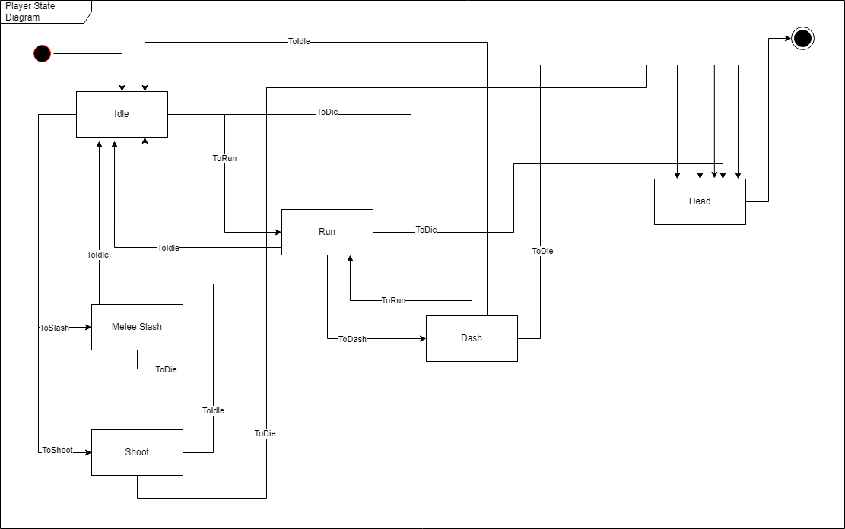

Image : Player State Diagram

|  |  |  |  |  |  |  |
| --- | --- | --- | --- | --- | --- | --- |
| Alias | State |  | No. | State | Action/Event | Result state |
| s0 | Initial state |  | 0 | s0 |  | s1 |
| s1 | Idle state |  | 1 | s1 | e2 | s2 |
| s2 | Run state |  | 2 | s1 | e4 | s4 |
| s3 | Dash state |  | 3 | s1 | e5 | s5 |
| s4 | Melee splash state |  | 4 | s1 | e6 | s6 |
| s5 | Shoot |  | 5 | s2 | e1 | s1 |
| s6 | Dead state |  | 6 | s2 | e3 | s3 |
| s7 | Final state |  | 7 | s2 | e6 | s6 |
|  |  |  | 8 | s3 | e1 | s1 |
| Alias | Action |  | 9 | s3 | e2 | s2 |
| e1 | ToIdle |  | 10 | s3 | e6 | s6 |
| e2 | ToRun |  | 11 | s4 | e1 | s1 |
| e3 | ToDash |  | 12 | s4 | e6 | s6 |
| e4 | ToSlash |  | 13 | s5 | e1 | s1 |
| e5 | ToShoot |  | 14 | s5 | e6 | s6 |
| e6 | ToDead |  | 15 | s6 |  | s7 |

### Slime state diagram

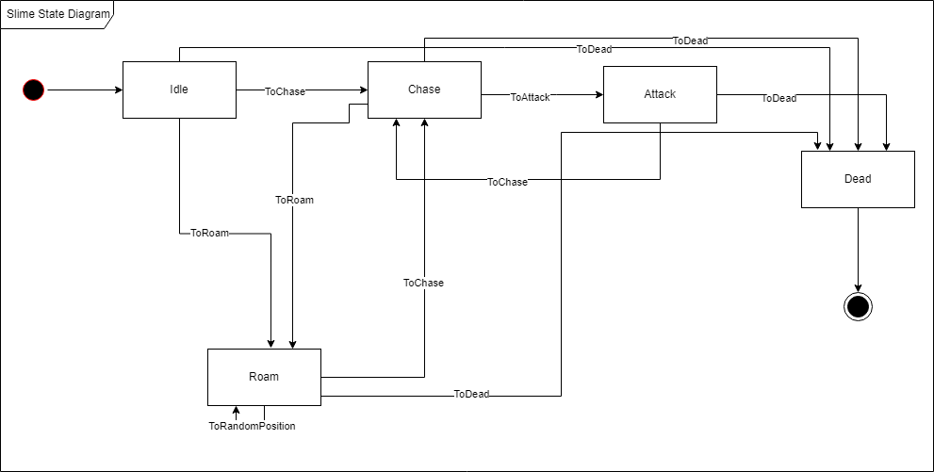

Image : Slime State Diagram

|  |  |  |  |  |  |  |
| --- | --- | --- | --- | --- | --- | --- |
| Alias | State |  | No. | State | Action/Event | Result state |
| s0 | Initial state |  | 1 | s0 |  | s1 |
| s1 | Idle state |  | 2 | s1 | e1 | s3 |
| s2 | Chase state |  | 3 | s1 | e0 | s2 |
| s3 | Roam state |  | 4 | s1 | e3 | s5 |
| s4 | Attack state |  | 5 | s2 | e1 | s3 |
| s5 | Dead state |  | 6 | s2 | e4 | s4 |
| s6 | Final state |  | 7 | s2 | e3 | s5 |
|  |  |  | 8 | s3 | e2 | s3 |
| Alias | Action |  | 9 | s3 | e0 | s2 |
| e0 | ToChase |  | 10 | s3 | e3 | s5 |
| e1 | ToRoam |  | 11 | s4 | e3 | s5 |
| e2 | ToRandomPostion |  | 12 | s4 | e0 | s2 |
| e3 | ToDead |  | 13 | s6 |  | s6 |
| e4 | ToAttack |  |  |  |  |  |

### Archer state diagram

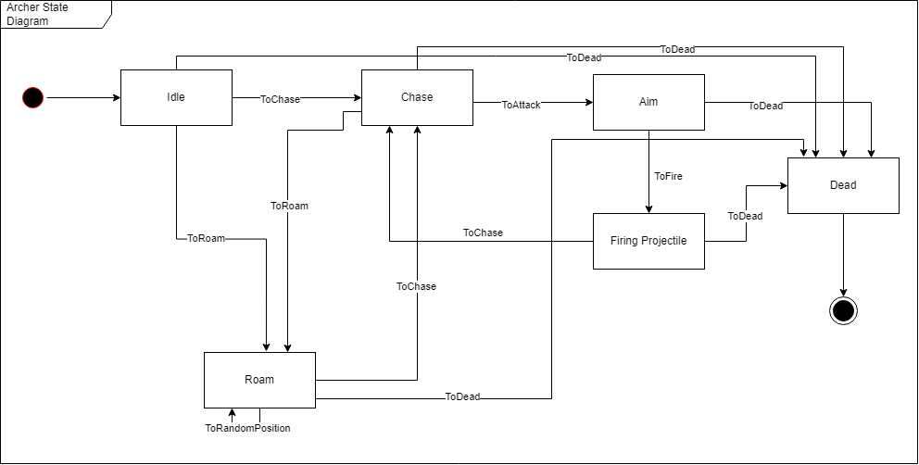

Image : Archer State Diagram

|  |  |  |  |  |  |  |
| --- | --- | --- | --- | --- | --- | --- |
| Alias | State |  | No. | State | Action/Event | Result state |
| s0 | Initial state |  | 0 | s0 |  | s1 |
| s1 | Idle state |  | 1 | s1 | e2 | s2 |
| s2 | Chase state |  | 2 | s1 | e3 | s3 |
| s3 | Roam state |  | 3 | s1 | e6 | s6 |
| s4 | Aim |  | 4 | s2 | e4 | s4 |
| s5 | Firing projectiles |  | 5 | s2 | e6 | s6 |
| s6 | Dead state |  | 6 | s3 | e7 | s3 |
| s7 | Final state |  | 7 | s3 | e2 | s2 |
|  |  |  | 8 | s3 | e6 | s6 |
| Alias | Action |  | 9 | s4 | e5 | s5 |
| e2 | ToChase |  | 10 | s4 | e6 | s6 |
| e3 | ToRoam |  | 11 | s5 | e6 | s6 |
| e4 | ToAttack |  | 12 | s6 |  | s7 |
| e5 | ToFire |  |  |  |  |  |
| e6 | ToDead |  |  |  |  |  |
| e7 | ToRandomPosition |  |  |  |  |  |

### Golem state diagram

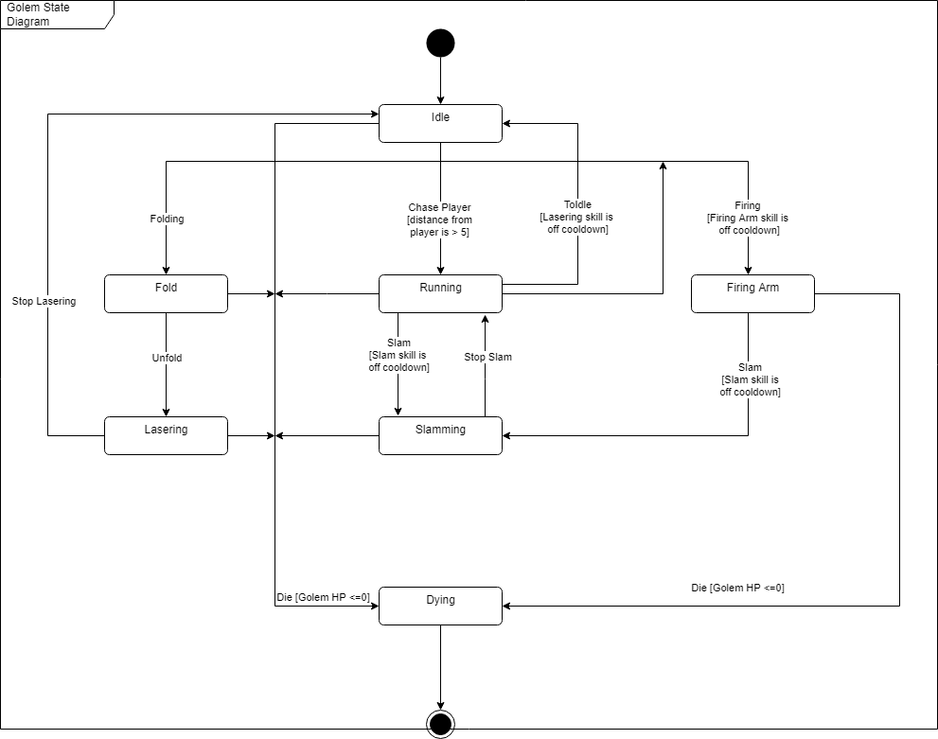

Image : Golem State Diagram

|  |  |  |  |  |  |  |
| --- | --- | --- | --- | --- | --- | --- |
| Alias | State |  | No. | State | Action/Event | Result state |
| s0 | Initial state |  | 0 | s0 |  | s1 |
| s1 | Idle |  | 1 | s1 | e2 | s2 |
| s2 | Running |  | 2 | s1 | e7 | s7 |
| s3 | Fold |  | 3 | s2 | e3 | s3 |
| s4 | Firing Arm |  | 4 | s2 | e4 | s4 |
| s5 | Lasering |  | 5 | s2 | e6 | s6 |
| s6 | Slamming |  | 6 | s2 | e7 | s7 |
| s7 | Dying |  | 7 | s3 | e1 | s1 |
| s8 | Final state |  | 8 | s3 | e7 | s7 |
|  |  |  | 9 | s4 | e6 | s6 |
| Alias | Action |  | 10 | s4 | e7 | s7 |
| e1 | ToIdle |  | 11 | s5 | e1 | s1 |
| e2 | Chase player |  | 12 | s5 | e7 | s7 |
| e3 | Folding |  | 13 | s6 | e8 | s2 |
| e4 | Firing |  | 14 | s6 | e7 | s7 |
| e5 | Unfold |  | 15 | s7 |  | s8 |
| e6 | Slam |  |  |  |  |  |
| e7 | Die |  |  |  |  |  |
| e8 | StopSlam |  |  |  |  |  |

### Bullet state diagram

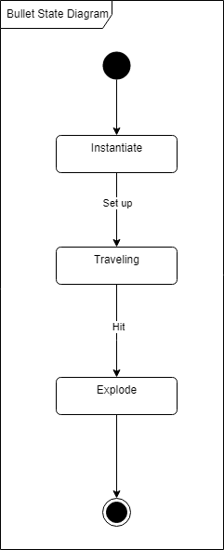

Image : Bullet State Diagram

|  |  |  |  |  |  |  |
| --- | --- | --- | --- | --- | --- | --- |
| Alias | State |  | No. | State | Action/Event | Result state |
| s0 | Initial state |  | 0 | s0 |  | s1 |
| s1 | instantiate |  | 1 | s1 | e0 | s2 |
| s2 | Traveling |  | 2 | s2 | e1 | s3 |
| s3 | Explode |  | 3 | s3 |  | s4 |
| s4 | Final state |  |  |  |  |  |
|  |  |  |  |  |  |  |
| Alias | Action |  |  |  |  |  |
| e0 | Set up |  |  |  |  |  |
| e1 | Hit |  |  |  |  |  |

### Non-Moving Object state diagram

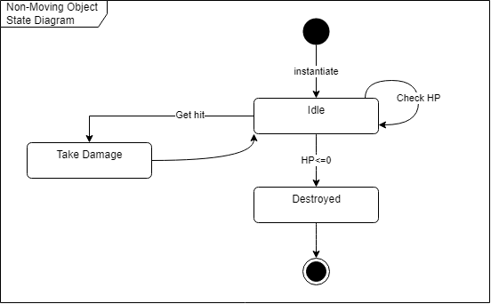

Image : Non-Moving Object State Diagram

|  |  |  |  |  |  |  |
| --- | --- | --- | --- | --- | --- | --- |
| Alias | State |  | No. | State | Action/Event | Result state |
| s0 | Initial state |  | 0 | s0 |  | s1 |
| s1 | Idle |  | 1 | s1 | e0 | s1 |
| s2 | Take damage |  | 2 | s1 | e2 | s2 |
| s3 | Destroyed |  | 3 | s1 | e1 | s3 |
| s4 | Final state |  | 4 | s2 |  | s1 |
|  |  |  | 5 | s3 |  | s4 |
| Alias | Action |  |  |  |  |  |
| e0 | Check HP |  |  |  |  |  |
| e1 | HP<=0 |  |  |  |  |  |
| e2 | GetHit |  |  |  |  |  |

### ShopNPC state diagram

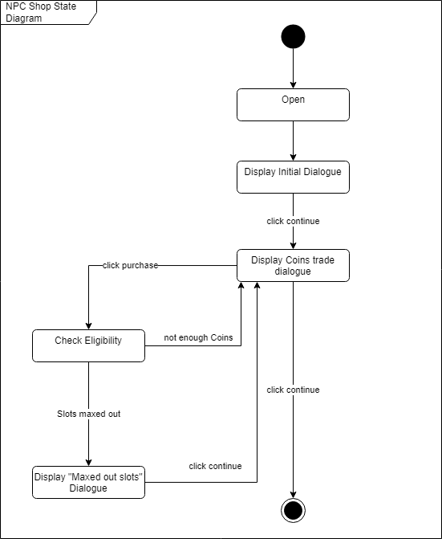

Image : Shop NPC State Diagram

|  |  |  |  |  |  |  |
| --- | --- | --- | --- | --- | --- | --- |
| Alias | State |  | No. | State | Action/Event | Result state |
| s0 | Initial state |  | 0 | s0 |  | s1 |
| s1 | Open |  | 1 | s1 |  | s2 |
| s2 | Display initial dialogue |  | 2 | s2 | e1 | s3 |
| s3 | Display coin trade dialogue |  | 3 | s3 | e1 | s4 |
| s4 | Check eligibility |  | 4 | s3 | e0 | s6 |
| s5 | Display "Maxed out slots" dialogue |  | 5 | s4 | e2 | s3 |
| s6 | Final state |  | 6 | s4 | e3 | s5 |
|  |  |  | 7 | s5 | e0 | s3 |
| Alias | Action |  |  |  |  |  |
| e0 | Click continue |  |  |  |  |  |
| e1 | click purchase |  |  |  |  |  |
| e2 | not enough coins |  |  |  |  |  |
| e3 | slots maxed out |  |  |  |  |  |

### Buff state diagram

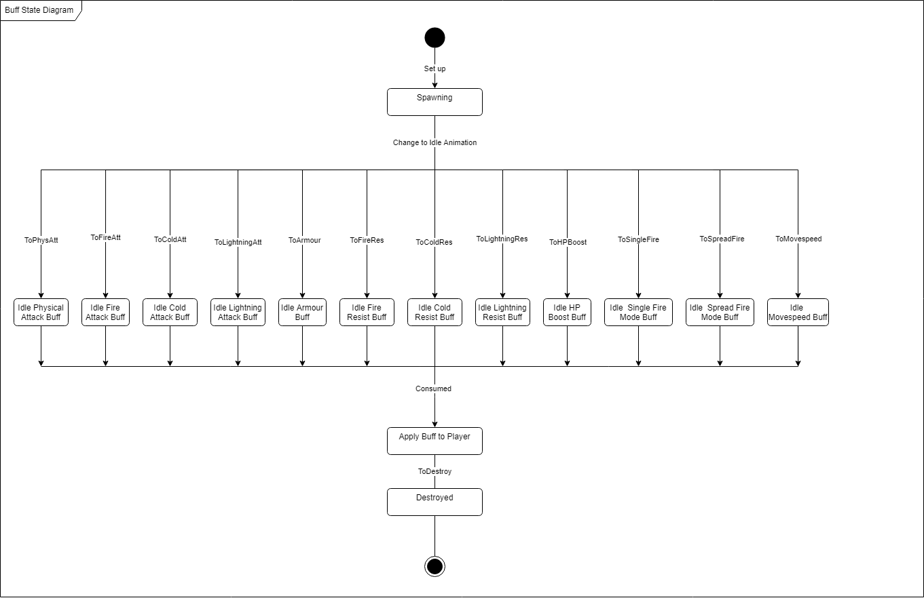

Image : Buff State Diagram

|  |  |  |  |  |  |  |  |
| --- | --- | --- | --- | --- | --- | --- | --- |
| Alias | State |  |  | No. | State | Action/Event | Result state |
| s0 | Initial state |  |  | 0 | s0 | e1 | s1 |
| s1 | Spawning |  |  | 1 | s1 | e2 | s2 |
| s2 | Idle Physical attack buff |  |  | 2 | s1 | e3 | s3 |
| s3 | idle fire attack buff |  |  | 3 | s1 | e4 | s4 |
| s4 | idle lightning attack buff |  |  | 4 | s1 | e5 | s5 |
| s5 | idle cold attack buff |  |  | 5 | s1 | e6 | s6 |
| s6 | idle armour buff |  |  | 6 | s1 | e7 | s7 |
| s7 | idle fire resist buff |  |  | 7 | s1 | e8 | s8 |
| s8 | idle lightning resist buff |  |  | 8 | s1 | e9 | s9 |
| s9 | idle cold resist buff |  |  | 9 | s1 | e10 | s10 |
| s10 | idle HP boost buff |  |  | 10 | s1 | e11 | s11 |
| s11 | idle spread fire mode buff |  |  | 11 | s1 | e12 | s12 |
| s12 | idle single fire mode buff |  |  | 12 | s1 | e13 | s13 |
| s13 | idle movespeed buff |  |  | 13 | s2 | e13 | s14 |
| s14 | Apply buff to player |  |  | 14 | s3 | e14 | s15 |
| s15 | Destroyed |  |  | 15 | s4 | e15 | s16 |
| s16 | Final state |  |  | 16 | s5 | e16 | s17 |
|  |  |  |  | 17 | s6 | e17 | s18 |
| Alias | Action |  |  | 18 | s7 | e18 | s19 |
| e1 | set up |  |  | 19 | s8 | e19 | s20 |
| e2 | ToPhysAtt |  |  | 20 | s9 | e20 | s21 |
| e3 | ToFireAtt |  |  | 21 | s10 | e21 | s22 |
| e4 | ToLightningAtt |  |  | 22 | s11 | e22 | s23 |
| e5 | ToColdAtt |  |  | 23 | s12 | e23 | s24 |
| e6 | ToFireRes |  |  | 24 | s13 | e24 | s25 |
| e7 | ToLightningRes |  |  | 25 | s14 | e14 | s15 |
| e8 | ToColdRes |  |  | 26 | s15 |  | s16 |
| e9 | ToHPBoost |  |  |  |  |  |  |
| e10 | ToSingleFire |  |  |  |  |  |  |
| e11 | ToSpreadFire |  |  |  |  |  |  |
| e12 | ToMovespeed |  |  |  |  |  |  |
| e13 | Consume |  |  |  |  |  |  |
| e14 | ToDestroy |  |  |  |  |  |  |

### ShieldEnemy state diagram

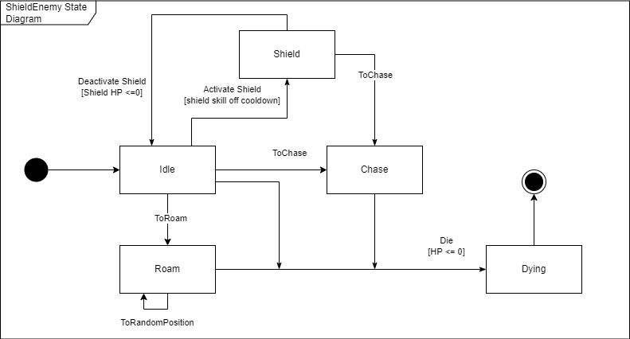

Image : Shield Enemy State Diagram

|  |  |  |  |  |  |  |
| --- | --- | --- | --- | --- | --- | --- |
| Alias | State |  | No. | State | Action/Event | Result state |
| s0 | Initial state |  | 1 | s0 |  | s1 |
| s1 | Idle |  | 2 | s1 | e1 | s3 |
| s2 | Roam |  | 3 | s1 | e2 | s2 |
| s3 | Chase |  | 4 | s1 | e4 | s4 |
| s4 | Shield |  | 5 | s2 | e3 | s2 |
| s5 | Dying |  | 6 | s4 | e5 | s1 |
| s6 | Final state |  | 7 | s1 | e6 | s5 |
|  |  |  | 8 | s2 | e6 | s5 |
| Alias | Action/Event |  | 9 | s3 | e6 | s5 |
| e1 | ToChase |  | 10 | s5 |  | s6 |
| e2 | ToRoam |  |  |  |  |  |
| e3 | ToRandomPosition |  |  |  |  |  |
| e4 | Activate Shield |  |  |  |  |  |
| e5 | Deactivate Shield |  |  |  |  |  |
| e6 | Die |  |  |  |  |  |

### Bomber state diagram

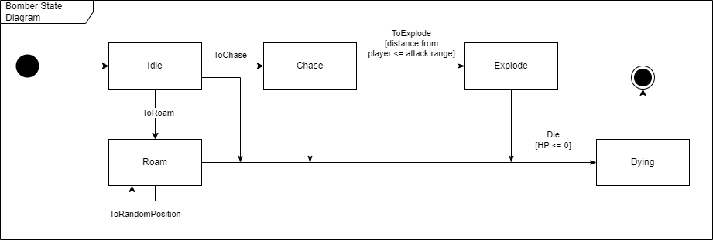

Image : Bomber State Diagram

|  |  |  |  |  |  |  |
| --- | --- | --- | --- | --- | --- | --- |
| Alias | State |  | No. | State | Action/Event | Result state |
| s0 | Initial state |  | 1 | s0 |  | s1 |
| s1 | Idle |  | 2 | s1 | e1 | s3 |
| s2 | Roam |  | 3 | s1 | e2 | s2 |
| s3 | Chase |  | 4 | s3 | e4 | s4 |
| s4 | Explode |  | 5 | s4 | e5 | s5 |
| s5 | Dying |  | 6 | s1 | e5 | s5 |
| s6 | Final state |  | 7 | s2 | e5 | s5 |
|  |  |  | 8 | s3 | e5 | s5 |
| Alias | Action/Event |  | 9 | s2 | e3 | s2 |
| e1 | ToChase |  | 10 | s5 |  | s6 |
| e2 | ToRoam |  |  |  |  |  |
| e3 | ToRandomPosition |  |  |  |  |  |
| e4 | ToExplode |  |  |  |  |  |
| e5 | Die |  |  |  |  |  |

### BringerOfDeathBoss state diagram

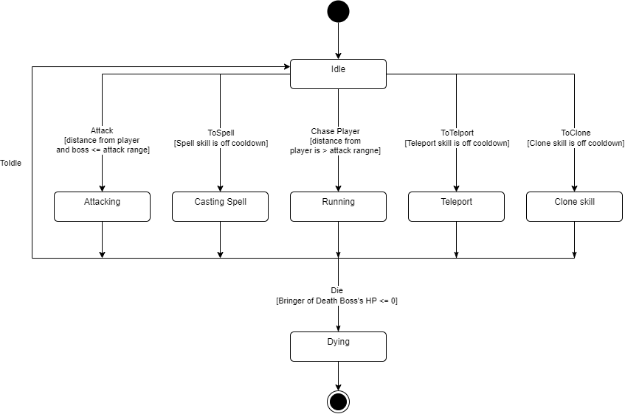

Image : Bringer of Death Boss State Diagram

|  |  |  |  |  |  |  |
| --- | --- | --- | --- | --- | --- | --- |
| Alias | State |  | No. | State | Action/Event | Result state |
| s0 | Initial state |  | 0 | s0 |  | s1 |
| s1 | Idle |  | 1 | s1 | e2 | s2 |
| s2 | Running |  | 2 | s1 | e3 | s3 |
| s3 | Casting Spell |  | 3 | s1 | e4 | s4 |
| s4 | Attacking |  | 4 | s1 | e5 | s5 |
| s5 | Teleport |  | 5 | s1 | e6 | s6 |
| s6 | Clone Skill |  | 6 | s2 | e1 | s1 |
| s7 | Dying |  | 7 | s3 | e1 | s1 |
| s8 | Final state |  | 8 | s4 | e1 | s1 |
|  |  |  | 9 | s5 | e1 | s1 |
| Alias | Action |  | 10 | s6 | e1 | s1 |
| e1 | ToIdle |  | 11 | s2 | e7 | s7 |
| e2 | Chase player |  | 12 | s3 | e7 | s7 |
| e3 | ToSpell |  | 13 | s4 | e7 | s7 |
| e4 | Attack |  | 14 | s5 | e7 | s7 |
| e5 | ToTeleport |  | 15 | s6 | e7 | s7 |
| e6 | ToClone |  | 16 | s7 |  | s8 |
| e7 | Die |  |  |  |  |  |

CHAPTER IV: DATA DESIGN

## Player data

The data is processed in respect of the player’s assigned slot when the user picks a save slot. Each one is named as "Player" + assigned slot + ".savefile".

The data is serialized and stored locally in the persistent path and can be deserialized to recover its usage in the game.

Tool used for serialization and deserialization:

* Library JsonUtility
* serialization : ToJson
* deserialization : FromJson

Persistent path location :

C:/Users/Username/AppData/LocalLow/DefaultCompany/DaGame

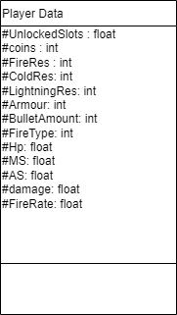

## Modifiers Data

The modifiers data are saved in a json file which is inside the game resource folder for ease of access.

Each modifier for now will be categorized into either “weapon modifier” group or “armour modifier” group and will have some basic properties like

{

"name":

"weight":,

"description":,

"popupMessage":{

"message”:,

"value":

}

}

Some modifiers with have their own custom properties like “range” if they have value that can be roll in a range of value. And some will have custom property that change how the player play the game like the “spread shot” modifer which will have properties like “attackSpeed”, “damageReduce” which are multipliers that affect player stats and how player shoot projectiles.

# CHAPTER V: STRUCTURAL DESIGN

## Game design

### Core Game Loop

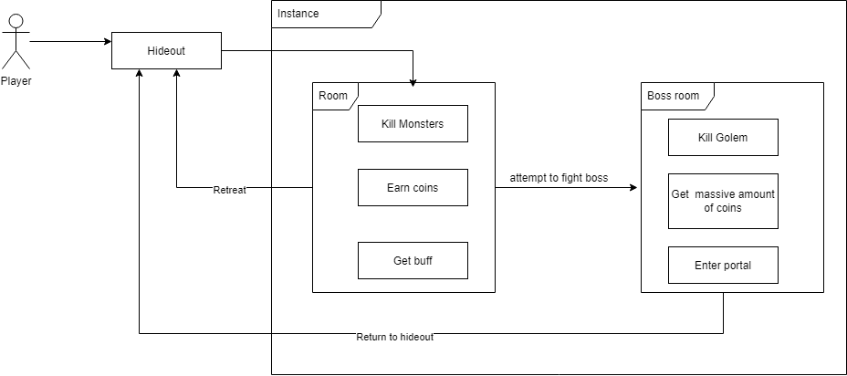

Image : The game structural design

The current core game loop is player enter an instance and kill all monster in a room then consume the buff that spawn. After that player move to another room and do the same. At the end of the instance there is a boss room player can enter the boss room and attempt to kill the boss but they can also retreat to hideout and keep 30% of the coins they found. Player can use that coins they earn to unlock slots to get random quirks depending on amount of slots they have to boost their stats before enter an instance. Rinse and repeat.

### Progression

Player progress through the game by collecting coins to unlock slots and use those slots to get random quirks at the beginning of each instance.

## Software design

We plan to use the model - view - controller architecture to design the game

* Model - game logic
* View - Graphics, 3D models, etc..
* Controller - Interface to the model

View

* User Action -> Controller
* Read state -> Model.State

Controller

* Write State -> Model.State
* Call Functions - > Model.function

Model

* State
* Functions

## Design Patterns Use

* Singleton:

Having concerned in the statement project, the game is dense with objects and classes. Most objects interact with the environment and react back to it and the player interacts with most of them also and the other way around. We implement the singleton pattern design for the player, AudioManager and more so that it can be referred globally and simplify the structure of our game.

# CHAPTER VI: INTERFACE DESIGN

## Regulation

* Make user interfaces consistent
* Accept user's errors
* Confirm detrimental actions
* Disable unsuitable functions contextually
* Use the screen effectively

## List of UI

|  |  |
| --- | --- |
| No. | Name |
| 1 | Main menu Screen |
| 2 | Player’s Health bar |
| 3 | Player stats sheet |
| 4 | Number Pop up |
| 5 | Player exit to menu and retreat to hideout |
| 6 | Tutorial UI |
| 7 | Coins counter |
| 8 | NPCShop |
| 9 | Interact with object buttons |
| 10 | Item tooltip |
| 11 | Inventory |

## Details description

### Main menu screen

The users will enter this scene first when they start the application. The scene will have a looped video as background, 1 text object for the game title, 3 buttons : Play, Tutorial and Quit.

Function:

* Play: Open save file slot for the user to choose
* Tutorial : move the user to tutorial scene
* Quit : quit the application

Upon pressing the Play button, the following gameobjects will get enabled : Save container 1 , 2 and 3,load button , create button, back button

Function:

* Save container Hold the information of the file slot such as coin, unlockable slot, display “none” if no save file was found.
* Back button : disable Save container 1 , 2 and 3, back button.
* Create button:If there is an already existing savefile, alert the user that the save file will get overwritten. Or else , create a new save file, assign the index of the slot to the player, make a new save file and send the user to the hideout scene
* Load button:If there is an already existing savefile, assign the index of the slot to the player, make a new save file and send the user to the hideout scene. Or else, notice the user that there is no save file found. If the player wants to proceed, assign the index of the slot to the player, make a new save file and send the user to the hideout scene.

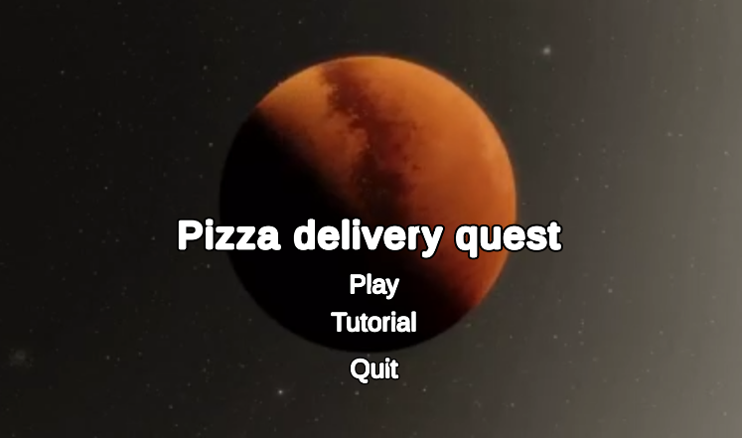

Image : Main menu UI

Image : Save slots options UI

### Player’s Health bar

#### Circular health bar

Active in any scene beside the main menu scene. It is composed of two main parts, the crescent part and the bar part. In the middle of the crescent part there is an illustration of the player and the text displaying current hp and max hp in the middle of the bar part which updates in every frame. The whole thing is stationed in the bottom right corner.

#### Status effect bar

Located next to the crescent part and above the bar part of the circular health bar, the status bar will add a status icon when the player receives a status effect and remove the icon whose active time runs out .Those icons are arranged in a grid like layout from left to right and from top to bottom.



Image : Player Health bar and Status Effect bar

### Player stats sheet

Existing in any scene beside the main menu scene , the player stat sheet is by default disabled. It’s activated only when the user is holding the tab button and it holds information like : hp , movespeed , attack speed , damage , armour , fire resistance , cold resistance , lightning resistance, etc in the form of text.

Image : Player Stat Sheet UI

### Number Pop up

Display a small number indicating the damage an entity is receiving . It appears on the head of the entity and ascends upward then disappears after a fixed amount of time

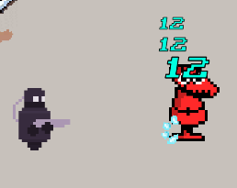

Image : Damage Pop Up

### Player exit to menu and retreat to hideout UI

Esc button will act as a trigger to turn on and off the UI. According to the active scene at the time being, one UI will show up. Player exit to menu will pop up if the player is in the hideout or the tutorial scene , retreat to hideout will pop up if the player is in an instance.

* Player exit to menu
  + Stop the time
  + Button to send the user back to the menu scene

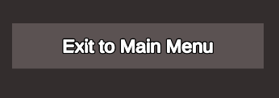

Image : Exit to main menu button UI

* Retreat to hideout
  + Text displaying the outcome if the user wants to return back to the hideout
  + Stop the time
  + Yes button to send the user back to the hideout
  + No button disables the retreat to hideout pop up and unfreezes time

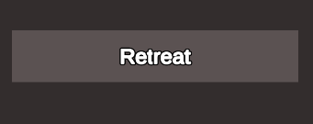

Image : Retreat button UI

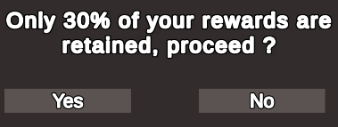

Image : Retreat Confirmation Button UI

### Tutorial UI

Return button in the tutorial scene, illustrated as a return arrow and located near the health bar. Pressing the button will reset the tutorial scene.



Image : Tutorial UI

### Coins counter

Active in any scene beside menu scene and tutorial scene. An illustration of a coin and text displays the amount the current player is holding. The text is updated every frame. The whole thing is placed in the top left corner of the scene

Image : Coin Counter UI

### NPCShop

Only existing in the hideout scene and is activated when the player with it, the NPCShop will contain 2 dialogue containers. Both the dialogue containers are formatted as , the dialogue box, the illustration of the npc on top of the box.

* First dialogue container
  + Text displays the greeting to player
  + Continue button : display the current dialogue box and activate the second one

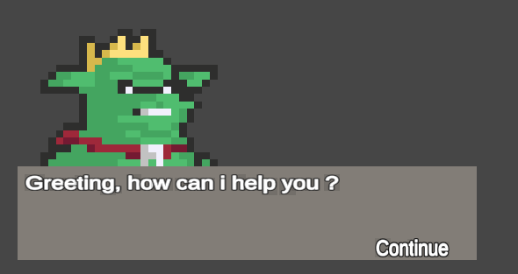

Image : NPC Dialogue 1

* Second dialogue container
  + Text displays :
    - N-th unlockable slot for the player to player and the price for it
    - If the player has reached the maximum unlockable slot, display “ has reached maximum number of unlockable slots”
  + Button to buy the unlockable slot placed near the text displaying the detail
  + Leave button : disable the current dialogue

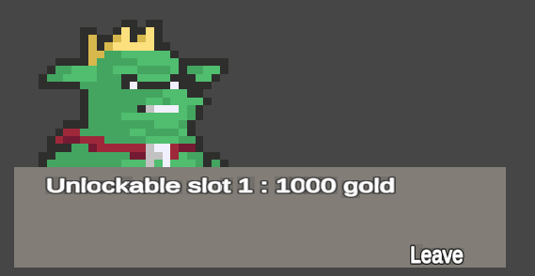

Image : NPC Dialogue 2

### Interact with object buttons

Illustrated as the key related to the action, the interact with object button is a small icon showing on top of the interactable gameobject when the player is near it and disappears when the player is out of range.

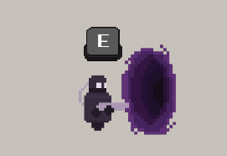

Image : Interact Button UI

### Item tooltip

Display the item modifiers and show what kind of effect will affect player if equiped. There is a “right mouse click” on the top left corner to to show how to equip the item and “ctrl + right mouse click” icon the the top right corner to show how to drop the item on the ground

Image : Item Tooltip UI

### Inventory

When player press “I” an Inventory UI appear and show all the items the player currently has equiped and in Inventory. Player can right click an item in the Inventory to equip it to the slot on the left. There are only 3 slots for player to equip so player need to choose what modifiers on an item are more important, and only 20 Inventory slots so player will need to leave some items behind if they’re not as good as others. Player can also right click an equiped item to unequip it. By pressing ctrl + right click on an item inside the Inventory player can throw the item on the ground

Image : Inventory UI

# CHAPTER VII: INSTALLATION

## Unity Hub and Editor

To gain access to the project source code and its editor , such tools are required. The guide to download and installing them visit [Installing Unity using the Hub](https://docs.unity3d.com/2018.3/Documentation/Manual/GettingStartedInstallingHub.html)

Unity editor system requirements

|  |  |  |  |
| --- | --- | --- | --- |
| Minimum requirements | Windows | macOS | Linux (Support in Preview) |
| Operating system version | Windows 7 (SP1+), Windows 10 and Windows 11, 64-bit versions only. | High Sierra 10.13+ | Ubuntu 20.04, Ubuntu 18.04, and CentOS 7 |
| CPU | X64 architecture with SSE2 instruction set support | X64 architecture with SSE2 instruction set support | X64 architecture with SSE2 instruction set support |
| Graphics API | DX10, DX11, and DX12-capable GPUs | Metal-capable Intel and AMD GPUs | OpenGL 3.2+ or Vulkan-capable, Nvidia and AMD GPUs. |
| Additional requirements | Hardware vendor officially supported drivers | Apple officially supported drivers | Gnome desktop environment running on top of X11 windowing system, Nvidia official proprietary graphics driver or AMD Mesa graphics driver. Other configuration and user environment as provided stock with the supported distribution (Kernel, Compositor, etc.) |
|  | For all operating systems, the Unity Editor is supported on workstations or laptop form factors, running without emulation, container or compatibility layer. | | |

## The game

The game will come in the form of a zip file. Extracting then the game client is ready, the file name is DaGame.exe

The link to download the game :

<https://github.com/asdqwe02/Project-NDC/releases/tag/v1.2.5>

You can also play the game on some of the io site that host the game like:

* <https://simmer.io/@BerryAlmond/project-ndc>
* <https://berryalmond.itch.io/project-ndc> (the password is 5qGQRk7ztNF8S8T)

Recommended system requirements

|  |  |
| --- | --- |
| Operating system | 32/64-bit Windows 7 / 8.1 / 10 |
| Processor | Intel Core i5 4460 or over |
| Memory | 6 GB RAM |
| Graphics | 128mb Video Memory, capable of Shader Model 2.0+ |
| DirectX | 11 |
| Storage | at least 2GBs |

# CHAPTER VIII: CONCLUSION

## Result

- Finished implementing 90% of the planned features

- Easy to understand UI

- Finished testing for the game

- Functional basic game loop

- Can easily expand and add more Buffs, Enemy types, bosses and new features

- Functional Buffs weighting system to use for spawning random Buffs and apply random Quirks

- Destroyable object in the game

- Working Buffs and Enemies

- Finished adding the Bringer of Death Boss Enemy, Bomber Enemy and Shield Enemy

- Sound system is finished and can be easily update if needed

- Item and their modifiers are finished and fully functional

## Limitations

- Due to time constraints and lack of manpower, we haven’t implemented the increase difficultly for next loop if player haven’t died

- We lack experience in developing and designing game so the game still feel bland

- Researching take more time than expected

- Lacking sound effect for some Enemy and Bosses, UI

- We haven’t followed the model – view – controller structure to the fullest extend

- The game is still simple and straightforward, lacking some exploration aspects of a dungeon crawler type of game

- Some functions still don’t work well to our liking and need to be refactored or revamp

- UI is still simplistic

- Lacking menu to control the sound volumn and no menu to change the game resolution

## Future Scope

- Adding more Enemy types

- More Elemental type

- Adding weapon swapping and more type of weapon and fire type

- More Bosses to fight

- Adding more sound to the game

- Improve UI

- Design more level that promote exploration and looting

- Adding NPC that sell buffs inside an instance instead of just in the hideout

- Add more items type and item modifiers

- Adding more character types with unique skills that player can choose

- Adding more game mechanic that challenge the player skill

- Adding cosmetic items

# REFERENCES

##### Unity

* <https://docs.unity3d.com/ScriptReference/Quaternion.html>
* <https://docs.unity3d.com/Manual/script-Serialization.html>
* <https://docs.unity3d.com/Manual/JSONSerialization.html>
* <https://docs.unity3d.com/ScriptReference/Application-persistentDataPath.html>
* <https://docs.unity3d.com/Manual/class-LineRenderer.html>
* <https://docs.unity3d.com/Manual/Navigation.html>
* <https://docs.unity3d.com/ScriptReference/Vector3.Lerp.html>
* <https://docs.unity3d.com/Manual/class-AnimatorController.html>
* <https://docs.unity3d.com/Manual/Prefabs.html>
* <https://docs.unity3d.com/Packages/com.unity.ugui@1.0/manual/UICanvas.html>
* <https://docs.unity3d.com/Packages/com.unity.ugui@1.0/manual/UIVisualComponents.html>
* <https://docs.unity3d.com/Packages/com.unity.ugui@1.0/manual/UIInteractionComponents.html>
* <https://docs.unity3d.com/Packages/com.unity.ugui@1.0/manual/EventSystem.html>

##### Unity Basic Tutorial (YouTube)

* <https://www.youtube.com/watch?v=FTxQKHG5WCA>
* <https://www.youtube.com/watch?v=2jTY11Am0Ig>
* <https://www.youtube.com/watch?v=Lvk6HKmWVwE>
* <https://www.youtube.com/watch?v=XF05X0fVz_o>
* <https://www.youtube.com/watch?v=Bc9lmHjqLZc>
* <https://www.youtube.com/watch?v=ygIC7DcXRCk>
* <https://www.youtube.com/watch?v=hkaysu1Z-N8&t=728s>
* <https://www.youtube.com/watch?v=Vrld13ypX_I>
* <https://www.youtube.com/watch?v=MKjWDtm5eeU>

* <https://www.youtube.com/watch?v=sPiVz1k-fEs>

##### Unity UI tutorial (YouTube/Forums)

* <https://www.youtube.com/watch?v=w6_fetj9PIw>
* <https://www.youtube.com/watch?v=U1LFOTDLh3o>
* <https://www.youtube.com/watch?v=d_qk7egZ8_c>
* <https://www.youtube.com/watch?v=_RIsfVOqTaE>
* <https://www.youtube.com/watch?v=HwdweCX5aMI&t=483s>
* <https://www.youtube.com/watch?v=YUcvy9PHeXs>
* <https://answers.unity.com/questions/828315/animated-sprite-in-ui-canvas.html>
* <https://forum.unity.com/threads/animating-sprites-in-a-canvas.281426/>
* <https://www.youtube.com/watch?v=VaDhk2eOQXM>
* <https://www.youtube.com/watch?v=JivuXdrIHK0>
* <https://answers.unity.com/questions/35579/destroy-object-at-a-set-distance.html>
* <https://answers.unity.com/questions/1414048/destroy-specific-gameobject-with-name.html>
* <https://www.codegrepper.com/code-examples/csharp/unity+create+a+child+object>

* <https://www.youtube.com/watch?v=LNLVOjbrQj4>

##### Assets “borrowed”

* <https://darkpixel-kronovi.itch.io/mecha-golem-free>
* <https://penusbmic.itch.io/>
* <https://elthen.itch.io/2d-pixel-art-goblin-king-sprites>
* <https://nyknck.itch.io/fx068>
* <https://nyknck.itch.io/pixel-arteffectfx023>
* <https://nyknck.itch.io/smoke-effect>
* <https://nyknck.itch.io/portal>
* <https://pimen.itch.io/fire-spell-effect-02>
* <https://elthen.itch.io/pixel-art-destructible-objects>
* <https://elthen.itch.io/2d-pixel-art-dungeon-collectables>

(note: some assets are too old or obscure and we can’t find it again)

##### Creating assets/VFX tutorial and tool use to create assets

* <https://www.youtube.com/watch?v=rLdA4Amea7Y>
* <https://www.youtube.com/watch?v=1CXVbCbqKyg>
* <https://www.youtube.com/watch?v=PoCN8yMoYu0>
* <https://www.youtube.com/watch?v=OAfpDaAKVSE>
* <https://www.youtube.com/watch?v=VvjIUIlso9M>

* <https://www.pixilart.com/draw>

##### Path finding

* <https://www.youtube.com/watch?v=jvtFUfJ6CP8>

##### Buff weight and pool references

* <https://www.gamedeveloper.com/design/loot-drop-best-practices>

* <http://www.vcskicks.com/random-element.php>

##### Fire rate reference

* <https://joshcgblog.wordpress.com/2015/12/07/2d-unity-game-bullets-and-fire-rate/>

##### Player’s Dash tutorial

* <https://www.youtube.com/watch?v=w4YV8s9Wi3w>
* <https://www.youtube.com/watch?v=Bf_5qIt9Gr8>

##### Audio Manager tutorial

* <https://www.youtube.com/watch?v=6OT43pvUyfY>
* <https://www.youtube.com/watch?v=QL29aTa7J5Q>

##### Item tooltip tutorial

* <https://youtu.be/U1LFOTDLh3o>
* <https://youtu.be/HXFoUGw7eKk>
* <https://youtu.be/d_qk7egZ8_c>
* <https://youtu.be/YUIohCXt_pc>

# WORKLOAD DISTRIBUTION

|  |  |  |
| --- | --- | --- |
| Patch 1.0 | Nguyễn Nhật Huy | Nguyễn Minh Thiện |
| Tilemap | 60% | 40% |
| Animation | 50% | 50% |
| UI | 60% | 40% |
| Physics | 50% | 50% |
| Interaction | 50% | 50% |
| Data design | 50% | 50% |
| Testing | 30% | 70% |
| Document | 50% | 50% |

|  |  |
| --- | --- |
| Patch 1.2.5 | Nguyễn Minh Thiện |
| Tilemap | 100% |
| Animation | 100% |
| UI | 100% |
| Physics | 100% |
| Interaction | 100% |
| Data design | 100% |
| Testing | 100% |
| Document | 100% |
| Researching | 100% |